**1.Introduction**

**1.1 Introduction of the Project**

Examination hall allotment and seating arrangement is a stand-alone application. Main purpose of this application is to handle the operations in an educational institute during the time examinations. All the students and staff can make use of this application without facing any issues as they get the information of the allotted seat and room number. Because of the flexibility of the application, it can be used on desktop as well as on mobile devices. To simplify examination hall allotment to staff and students and seating arrangement for the student, Exam Hall seating arrangement System was developed. Allocation of rooms to staff and students was done manually which was a tedious task and would be time consuming. To overcome this disadvantage Exam Hall seating arrangement System was developed. Details in modules such as Students Details, Examination Timing Details, and Hall Details with the proper descriptions will be monitored. Main aim for developing this application is to simplify, the manual work done for allotment of hall and seats. This allocation of seats to be done in such a way that each student getting a seat without any clash. Students feel difficulty in searching the seat allotted in the exam hall, as they’ll be tensed during the exams, this application is helpful for both the staff and students which will automatically generate their seating arrangement and it will also allocate particular invigilator for particular hall. Manual paper work is automated depending on the department numbers and registration numbers. In most of the institute’s details of staff, non-teaching staff, student all are maintained manually, which is time consuming, prone to errors and it will add up as a stack of hardcopies. Existing system where manually allocation of seating arrangement is done, making the system inefficient, ineffective and less accurate, report generation becomes complex task.

**1.2 Existing Project**

In the existing system, exam seats are arranged for the individual students of same course by the course teachers. Since this seating arrangement is done manually it is difficult to maintain the quality of exam, as this system is less accurate and prone to errors. Allocation of rooms to staff & students was done manually which was a tedious task, requiring more manpower, more paper work and would be time consuming. To overcome these disadvantages Exam Hall seating arrangement System was developed.

* 1. **Problem Statement**
* In existing system allocation of seating arrangement is done manually, which consumes lot of paper and time.
* Most of the students feel Augean to search their allotted seat during exam.

**1.4 Proposed System**

Main purpose of developing the Exam Hall seating system is to generate hassle free seats for the students automatically. This application allots the staff and students the exam hall automatically and ensures that no two students are allotted on same seat.

**1.5 Advantage of Proposed System**

* Easy to handle and operate.
* Friendly interface.
* Fast and convenient.
* Less human effort.
* Easy to update.
* Easy message passing.

**2. FEASIBILITY STUDY**

The feasibility of the project is analysed in this phase and business proposal is put forth with a very general plan for the project and some cost estimates. During system analysis the feasibility study of the proposed system is to be carried out. This is to ensure that the proposed system is not a burden to the company. For feasibility analysis, some understanding of the major requirements for the system is essential.

The development and implementation of a new system is definitely expensive. It requires system resources, manpower, time and money. So, it increases the necessity of the feasibility study based on the proposed system requirements.

**Three key conditions involved in the feasibility analysis are:**

* + - * Economical Feasibility
      * Technical Feasibility
      * Social Feasibility

**2.1 ECONOMICAL FEASIBILITY:**

The study is carried out to check the economic impact that the system will have on the organization. The amount of fund that the company can pour into the research and development of the system is limited. The expenditures must be justified. Economic feasibility analysis is the most commonly used method for determining the efficiency of a new project. It is also known as cost analysis. It helps in identifying profit against investment expected from a project. Cost and time are the most essential factors involved in this field of study.

According to our project the economic cost is very least compare to present economy.

**2.2 TECHNICAL FEASIBILTY:**

This assessment is based on the outline design of system requirements. Technical feasibility study is the complete study of the project in items of input, processes, output, fields, programs and procedures. It is a very effective tool for long term planning and trouble shooting. The technical feasibility study should most essentially support the financial information of an organization. It determines whether the company has the technical expertise to handle completion of the project.

According to our project manual data can be stored in database.

**2.3 SOCIAL FEASIBILITY:**

Social impact analysis / social feasibility. Social Impact Assessment (SIA) is a process that provides a framework for prioritizing, gathering, and incorporating social information and participation into the design and delivery of projects. It ensures that infrastructure project development is:

* Informed and takes into account the key relevant social issues, and
* Incorporates a participation strategy for involving a wide range of stakeholders

At the micro-level, SIA impacts on individuals, at the meso-level it impacts on collectives (e.g., Groups of people and organization) and at the macro-level it impacts on social macro-systems (e.g., National and international political and legal systems).

**3. SYSTEM REQUIRED SPECIFICATION**

**3.1** **Hardware Requirement Components**

Hardware refers to the item in a PC that can be touched and felt like keyboard, monitor, mouse, and the system unit. Additional hardware components that can be added to the PC are modem, printer, scanner etc.

**The hardware thus used here are consists of:**

**PROCESSOR:** INTEL CORE 3

**RAM:** 8GB

**HDD:** 1 TB

**MONITOR:** 15.9 LCD DISPLAY

**3.2 Software Requirements Components**

There is use of large software in developing this project. Software is the logical program that handles different components, which cannot be touched or felt and helps to interact with one another in a hassle-free manner.

**The software used her consists of:**

**FRONT END:** VB.NET

**BACK END:** Microsoft SQL Server Database

**DEVELOPING TOOL:** MS visual Studio 2010

**OPEARATING SYSTEM:** WINDOWS 7

**4. MODULE DESCRIPTION)**

**Login:** Used by admin and faculty to login.

**Room creation:** Listing out the rooms and number of benches present in each room.

**Staff creation:** To register details of staff.

**Student creation:** To upload the students file and also to register the particular student.

**Exam assign:** Details of exam like date and type of exam conducted is assigned in this module.

**5. LIST OF TABLES**

**5.1. LOGIN**

|  |  |
| --- | --- |
| **NAME** | **DATATYPE** |
| User Name | Nvarchar(50) |
| Password | Nvarchar(50) |

**5.2. COURSE**

|  |  |
| --- | --- |
| **NAME** | **DATATYPE** |
| Course | Nvarchar(50) |
| Details | Nvarchar(50) |
| Specification | Nvarchar(50) |

**5.3. DATES**

|  |  |
| --- | --- |
| **NAME** | **DATATYPE** |
| Exam Name | Nvarchar(50) |
| Details | Nvarchar(50) |
| Branch | Nvarchar(50) |
| Semester | Nvarchar(50) |
| Subject | Nvarchar(50) |
| Date | Nvarchar(50) |

**5.4. SEAT ALLOCATION**

|  |  |
| --- | --- |
| **NAME** | **DATATYPE** |
| Branch | Nvarchar(50) |
| Semester | Nvarchar(50) |
| Subject | Nvarchar(50) |
| Exam Details | Nvarchar(50) |
| Exam Date | Nvarchar(50) |
| Total Student | Nvarchar(50) |
| Allocate Room | Nvarchar(50) |
| Seat Available | Nvarchar(50) |

**5.5. ROOM**

|  |  |
| --- | --- |
| **NAME** | **DATATYPE** |
| Room No. | Nvarchar(50) |
| Floor | Nvarchar(50) |
| Benches | Nvarchar(50) |

**5.6. STUDENTS DETAILS**

|  |  |
| --- | --- |
| **NAME** | **DATATYPE** |
| Reg No. | Nvarchar(50) |
| Student Name | Nvarchar(50) |
| Parent Name | Nvarchar(50) |
| Address | Nvarchar(MAX) |
| Phono no. | Nvarchar(50) |
| Course | Nvarchar(50) |
| Semester | Nvarchar(50) |
| Specification | Nvarchar(50) |

**5.7. SUBJECT**

|  |  |
| --- | --- |
| **NAME** | **DATATYPE** |
| Course Name | Nvarchar(50) |
| Semester | Nvarchar(50) |
| Subject Short Name | Nvarchar(50) |
| Subject Full Name | Nvarchar(50) |

**5.8. Assign**

|  |  |
| --- | --- |
| **NAME** | **DATATYPE** |
| Exam Name | Nvarchar(50) |
| Date | Nvarchar(50) |
| Staff Code | Nvarchar(50) |
| Staff Name | Nvarchar(50) |
| Assign To | Nvarchar(50) |

**5.9. Staff**

|  |  |
| --- | --- |
| **NAME** | **DATATYPE** |
| Staff Code | Nvarchar(50) |
| Staff Name | Nvarchar(50) |
| Qualification | Nvarchar(50) |
| Designation | Nvarchar(50) |
| Email Id | Nvarchar(50) |
| Phone Number | Nvarchar(50) |

**6. DESIGN AND IMPLEMENTATION**

**6.1 ER-Diagram**

ER model stands for Entity-Relationship model. It describes inter-related things of interest in a specific domain of knowledge. A basic ER model is composed of entity types (which classify the things of interest) and specifies relationships that can exist between entities (instances of those entity types).

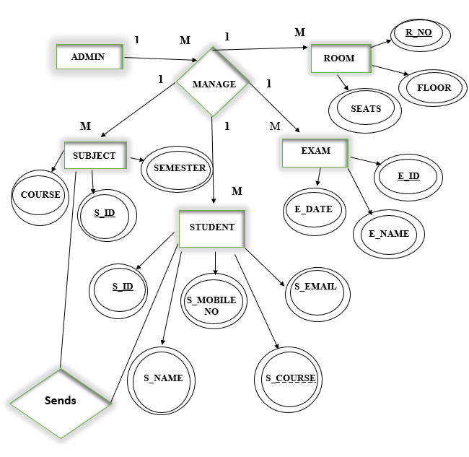

**6.2 DFD**

A data-flow-diagram is a way of representing a flow of data through a process or a system (usually an information system). The DFD also provides information about the outputs and inputs of each entity and the process itself. A Data-Flow-diagram has no control flow-there are no decision rules and no loops.

**6.2.1 DFD Level 0**- IT is also called as Context Diagram. It’s basic overview of the whole system or process begin analysed or modelled.

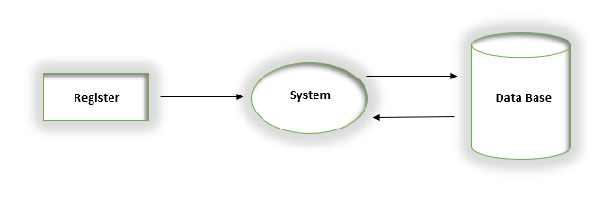

**6.2.2 DFD Level 1-** It provides a more detailed breakout of pieces of Context level Diagram.

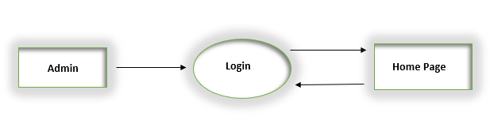

**6.2.3 DFD Level 2-**It may require more text to reach the necessary level of detail about the system’s functioning.

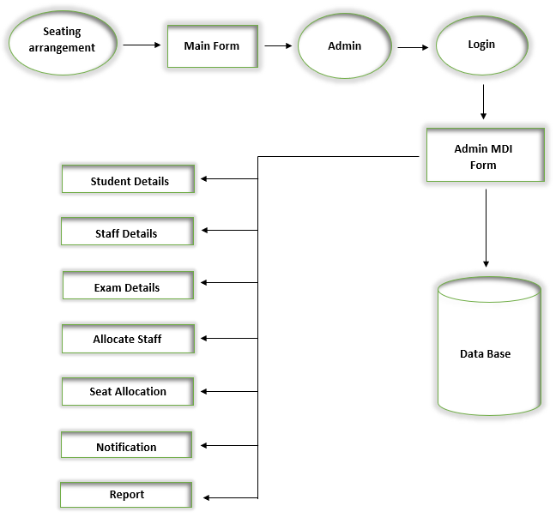

**6.3 UML DIAGRAM**

The Unified Modelling Language (UML) is a general purpose , development, modelling language in the field of software engineering that is intended to provide a standard way to visualize the design of a system.

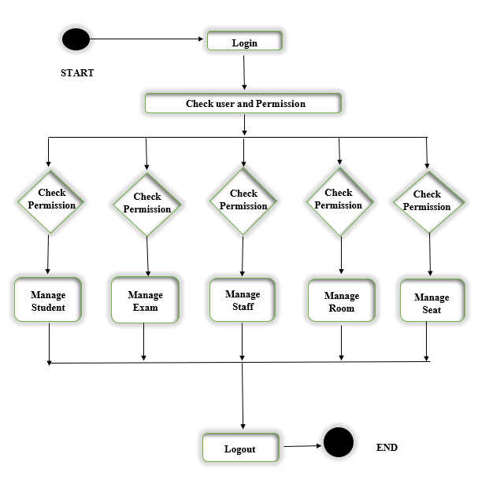

**7. CODING**

**7.1 Source Code**

**7.1.1 Module Code**

Imports System.Data.SqlClient

Module Module1

Public regnovar, appexamvar, q1Var, q2Var As String

Public Conn As New SqlConnection("Data Source=.\SQLEXPRESS;AttachDbFilename=|DataDirectory|\EducationSystem.mdf;Integrated Security=True;User Instance=True")

End Module

**7.1.2 Splash Screen Form Code**

Public Class Form1

Dim i As Integer

Private Sub Timer1_Tick(ByVal sender As System.Object, ByVal e As System.EventArgs) Handles Timer1.Tick

If ProgressBar1.Value >= 100 Then

Timer1.Stop()

Me.Hide()

login.Show()

Else

ProgressBar1.Value += 10

Label3.Text = ProgressBar1.Value & ("%")

End If

End Sub

Private Sub Form1_Load(ByVal sender As System.Object, ByVal e As System.EventArgs) Handles MyBase.Load

Timer1.Start()

End Sub

Private Sub ProgressBar1_Click(ByVal sender As System.Object, ByVal e As System.EventArgs) Handles ProgressBar1.Click

End Sub

End Class

**7.1.3 Login Form Code**

Imports System.Data.SqlClient

Public Class login

Private Sub Button2_Click(ByVal sender As System.Object, ByVal e As System.EventArgs) Handles Button2.Click

TextBox1.Clear()

TextBox2.Clear()

End Sub

Private Sub Button1_Click(ByVal sender As System.Object, ByVal e As System.EventArgs) Handles Button1.Click

If Conn.State = ConnectionState.Open Then Conn.Close()

Conn.Open()

Dim Cmd0 As New SqlCommand("select*from login where username='" & UCase(TextBox1.Text) & "' and password='" & TextBox2.Text & "'", Conn)

Dim D1 As SqlDataReader = Cmd0.ExecuteReader()

If D1.HasRows Then

MDIParent1.Show()

Me.Hide()

If Conn.State = ConnectionState.Open Then Conn.Close()

Else

MsgBox("user or password is not correct please check")

End If

End Sub

End Class

**7.1.4 MDI Form Code**

Imports System.Windows.Forms

Public Class MDIParent1

Private Sub ShowNewForm(ByVal sender As Object, ByVal e As EventArgs)

' Create a new instance of the child form.

Dim ChildForm As New System.Windows.Forms.Form

' Make it a child of this MDI form before showing it.

ChildForm.MdiParent = Me

m_ChildFormNumber += 1

ChildForm.Text = "Window " & m_ChildFormNumber

ChildForm.Show()

End Sub

Private Sub OpenFile(ByVal sender As Object, ByVal e As EventArgs)

Dim OpenFileDialog As New OpenFileDialog

OpenFileDialog.InitialDirectory = My.Computer.FileSystem.SpecialDirectories.MyDocuments

OpenFileDialog.Filter = "Text Files (*.txt)|*.txt|All Files (*.*)|*.*"

If (OpenFileDialog.ShowDialog(Me) = System.Windows.Forms.DialogResult.OK) Then

Dim FileName As String = OpenFileDialog.FileName

' TODO: Add code here to open the file.

End If

End Sub

Private Sub SaveAsToolStripMenuItem_Click(ByVal sender As Object, ByVal e As EventArgs)

Dim SaveFileDialog As New SaveFileDialog

SaveFileDialog.InitialDirectory = My.Computer.FileSystem.SpecialDirectories.MyDocuments

SaveFileDialog.Filter = "Text Files (*.txt)|*.txt|All Files (*.*)|*.*"

If (SaveFileDialog.ShowDialog(Me) = System.Windows.Forms.DialogResult.OK) Then

Dim FileName As String = SaveFileDialog.FileName

' TODO: Add code here to save the current contents of the form to a file.

End If

End Sub

Private Sub ExitToolsStripMenuItem_Click(ByVal sender As Object, ByVal e As EventArgs)

Me.Close()

End Sub

Private Sub CutToolStripMenuItem_Click(ByVal sender As Object, ByVal e As EventArgs)

' Use My.Computer.Clipboard to insert the selected text or images into the clipboard

End Sub

Private Sub CopyToolStripMenuItem_Click(ByVal sender As Object, ByVal e As EventArgs)

' Use My.Computer.Clipboard to insert the selected text or images into the clipboard

End Sub

Private Sub PasteToolStripMenuItem_Click(ByVal sender As Object, ByVal e As EventArgs)

'Use My.Computer.Clipboard.GetText() or My.Computer.Clipboard.GetData to retrieve information from the clipboard.

End Sub

Private Sub ToolBarToolStripMenuItem_Click(ByVal sender As Object, ByVal e As EventArgs)

End Sub

Private Sub StatusBarToolStripMenuItem_Click(ByVal sender As Object, ByVal e As EventArgs)

End Sub

Private Sub CascadeToolStripMenuItem_Click(ByVal sender As Object, ByVal e As EventArgs)

End Sub

Private Sub TileVerticalToolStripMenuItem_Click(ByVal sender As Object, ByVal e As EventArgs)

End Sub

Private Sub TileHorizontalToolStripMenuItem_Click(ByVal sender As Object, ByVal e As EventArgs)

End Sub

Private Sub ArrangeIconsToolStripMenuItem_Click(ByVal sender As Object, ByVal e As EventArgs)

End Sub

Private Sub CloseAllToolStripMenuItem_Click(ByVal sender As Object, ByVal e As EventArgs)

' Close all child forms of the parent.

For Each ChildForm As Form In Me.MdiChildren

ChildForm.Close()

Next

End Sub

Private m_ChildFormNumber As Integer

Private Sub SubjectToolStripMenuItem_Click(ByVal sender As System.Object, ByVal e As System.EventArgs) Handles SubjectToolStripMenuItem.Click

subject.MdiParent = Me

subject.Show()

End Sub

Private Sub CourseToolStripMenuItem_Click(ByVal sender As System.Object, ByVal e As System.EventArgs) Handles CourseToolStripMenuItem.Click

course.MdiParent = Me

course.Show()

End Sub

Private Sub roomToolStripMenuItem_Click(ByVal sender As System.Object, ByVal e As System.EventArgs) Handles StudentdetailsToolStripMenuItem.Click

room.MdiParent = Me

room.Show()

End Sub

Private Sub examdetailsToolStripMenuItem_Click(ByVal sender As System.Object, ByVal e As System.EventArgs) Handles NotificationToolStripMenuItem.Click

examdetails.MdiParent = Me

examdetails.Show()

End Sub

Private Sub notificationToolStripMenuItem_Click(ByVal sender As System.Object, ByVal e As System.EventArgs) Handles AddReportsToolStripMenuItem.Click

notification.MdiParent = Me

notification.Show()

End Sub

Private Sub studentDetailsToolStripMenuItem_Click(ByVal sender As System.Object, ByVal e As System.EventArgs) Handles ExamDetailsToolStripMenuItem.Click

studentdetails.MdiParent = Me

studentdetails.Show()

End Sub

Private Sub reportsToolStripMenuItem_Click(ByVal sender As System.Object, ByVal e As System.EventArgs) Handles SeatAllocationToolStripMenuItem.Click

End Sub

Private Sub SeatAllocationToolStripMenuItem1_Click(ByVal sender As System.Object, ByVal e As System.EventArgs) Handles SeatAllocationToolStripMenuItem1.Click

seatallocation.MdiParent = Me

seatallocation.Show()

End Sub

Private Sub ExamreportToolStripMenuItem_Click(ByVal sender As System.Object, ByVal e As System.EventArgs) Handles ExamreportToolStripMenuItem.Click

examreport.MdiParent = Me

examreport.Show()

End Sub

Private Sub StudentReportToolStripMenuItem_Click(ByVal sender As System.Object, ByVal e As System.EventArgs) Handles StudentReportToolStripMenuItem.Click

studentreport.MdiParent = Me

studentreport.Show()

End Sub

Private Sub SubjectReportToolStripMenuItem_Click(ByVal sender As System.Object, ByVal e As System.EventArgs) Handles SubjectReportToolStripMenuItem.Click

subjectreport.MdiParent = Me

subjectreport.Show()

End Sub

Private Sub BranchReportToolStripMenuItem_Click(ByVal sender As System.Object, ByVal e As System.EventArgs) Handles BranchReportToolStripMenuItem.Click

branchreport.MdiParent = Me

branchreport.Show()

End Sub

Private Sub RoomReportToolStripMenuItem_Click(ByVal sender As System.Object, ByVal e As System.EventArgs) Handles RoomReportToolStripMenuItem.Click

roomreport.MdiParent = Me

roomreport.Show()

End Sub

Private Sub EXITToolStripMenuItem1_Click(ByVal sender As System.Object, ByVal e As System.EventArgs) Handles EXITToolStripMenuItem1.Click

Me.Close()

login.Show()

End Sub

Private Sub AllocateStaffToolStripMenuItem_Click(ByVal sender As System.Object, ByVal e As System.EventArgs) Handles AllocateStaffToolStripMenuItem.Click

assign.MdiParent = Me

assign.Show()

End Sub

Private Sub StaffrDetailsToolStripMenuItem_Click(ByVal sender As System.Object, ByVal e As System.EventArgs) Handles StaffrDetailsToolStripMenuItem.Click

staff.MdiParent = Me

staff.Show()

End Sub

Private Sub StaffReportToolStripMenuItem_Click(ByVal sender As System.Object, ByVal e As System.EventArgs) Handles StaffReportToolStripMenuItem.Click

staffreport.MdiParent = Me

staffreport.Show()

End Sub

Private Sub AllocationReportToolStripMenuItem_Click(ByVal sender As System.Object, ByVal e As System.EventArgs) Handles AllocationReportToolStripMenuItem.Click

allocationreport.MdiParent = Me

allocationreport.Show()

End Sub

End Class

**7.1.5 Course Form Code**

Imports System.Data.SqlClient

Imports System.Text.RegularExpressions

Public Class course

Sub saverecord()

Dim q1var, q2var As String

If TextBox1.Text = "" Then

MsgBox("Please enter the valid imput")

Exit Sub

End If

If Conn.State = ConnectionState.Open Then Conn.Close()

Conn.Open()

Dim Cmd0 As New SqlCommand(" select course from course where course='" & TextBox1.Text & "'", Conn)

Dim D1 As SqlDataReader = Cmd0.ExecuteReader()

If D1.HasRows Then

MsgBox("This record is already present in the database")

If Conn.State = ConnectionState.Open Then Conn.Close()

Exit Sub

End If

If Conn.State = ConnectionState.Open Then Conn.Close()

Conn.Open()

q1var = "insert into course("

q2var = "values("

q1var = q1var & "course" & ","

q2var = q2var & "'" & TextBox1.Text & "',"

q1var = q1var & "details" & ")"

q2var = q2var & "'" & TextBox2.Text & "')"

'MsgBox(q1var & q2var)

Dim cmd1 As New SqlCommand(q1var & q2var, Conn)

cmd1.ExecuteNonQuery()

If Conn.State = ConnectionState.Open Then Conn.Close()

disRecords()

MsgBox("Course added Successfully")

End Sub

Sub disRecords()

If Conn.State = ConnectionState.Open Then Conn.Close()

Conn.Open()

Dim DS1 As New DataSet

Dim adp As New SqlDataAdapter("select * from course order by course", Conn)

adp.Fill(DS1)

DataGridView1.DataSource = DS1.Tables(0)

If Conn.State = ConnectionState.Open Then

Conn.Close()

End If

End Sub

Private Sub Button1_Click(ByVal sender As System.Object, ByVal e As System.EventArgs) Handles Button1.Click

saverecord()

End Sub

Private Sub Button4_Click(ByVal sender As System.Object, ByVal e As System.EventArgs) Handles Button4.Click

TextBox1.Clear()

TextBox2.Clear()

End Sub

Private Sub Form3_Load(ByVal sender As System.Object, ByVal e As System.EventArgs) Handles MyBase.Load

disRecords()

End Sub

Dim tempVar As String

Private Sub Button3_Click(ByVal sender As System.Object, ByVal e As System.EventArgs) Handles Button3.Click

tempVar = DataGridView1.CurrentRow.Cells(0).Value

If Conn.State = ConnectionState.Open Then Conn.Close()

Conn.Open()

Dim cmd0 As New SqlCommand("delete from course where course='" & tempVar & "'", Conn)

cmd0.ExecuteNonQuery()

disRecords()

End Sub

Private Sub Button2_Click(ByVal sender As System.Object, ByVal e As System.EventArgs) Handles Button2.Click

tempVar = DataGridView1.CurrentRow.Cells(0).Value

If Conn.State = ConnectionState.Open Then Conn.Close()

Conn.Open()

Dim cmd0 As New SqlCommand("delete from course where course='" & tempVar & "'", Conn)

cmd0.ExecuteNonQuery()

saverecord()

End Sub

Private Sub DataGridView1_CellContentClick(ByVal sender As System.Object, ByVal e As System.Windows.Forms.DataGridViewCellEventArgs) Handles DataGridView1.CellContentClick

tempVar = DataGridView1.CurrentRow.Cells(0).Value

If Conn.State = ConnectionState.Open Then Conn.Close()

Conn.Open()

Dim cmd0 As New SqlCommand("select * from course where course='" & tempVar & "'", Conn)

Dim D1 As SqlDataReader = cmd0.ExecuteReader

If D1.HasRows Then

D1.Read()

TextBox1.Text = D1(0).ToString

TextBox2.Text = D1(1).ToString

End If

End Sub

Private Sub TextBox1_Leave(ByVal sender As Object, ByVal e As System.EventArgs) Handles TextBox1.Leave

If Not Regex.Match(TextBox1.Text, "^[a-z. ]*$", RegexOptions.IgnoreCase).Success Then

MsgBox("Please enter alphabets only")

TextBox1.Clear()

TextBox1.Focus()

End If

End Sub

Private Sub TextBox1_TextChanged(ByVal sender As System.Object, ByVal e As System.EventArgs) Handles TextBox1.TextChanged

End Sub

Private Sub Button5_Click(ByVal sender As System.Object, ByVal e As System.EventArgs) Handles Button5.Click

Me.Close()

MDIParent1.Show()

End Sub

End Class

**7.1.6 Subject Form Code**

Imports System.Data.SqlClient

Imports System.Text.RegularExpressions

Public Class subject

Sub saverecord()

Dim q1var, q2var As String

If TextBox1.Text = "" Then

MsgBox("Please enter the valid input")

Exit Sub

End If

If Conn.State = ConnectionState.Open Then Conn.Close()

Conn.Open()

Dim Cmd0 As New SqlCommand(" select subjectshortname from subject where subjectshortname='" & TextBox1.Text & "'", Conn)

Dim D1 As SqlDataReader = Cmd0.ExecuteReader()

If D1.HasRows Then

MsgBox("This record is already present in the database")

If Conn.State = ConnectionState.Open Then Conn.Close()

Exit Sub

End If

If Conn.State = ConnectionState.Open Then Conn.Close()

Conn.Open()

q1var = "insert into subject("

q2var = "values("

q1var = q1var & "coursename" & ","

q2var = q2var & "'" & ComboBox1.Text & "',"

q1var = q1var & "semester" & ","

q2var = q2var & "'" & ComboBox2.Text & "',"

q1var = q1var & "subjectshortname" & ","

q2var = q2var & "'" & TextBox1.Text & "',"

q1var = q1var & "subjectfullname" & ","

q2var = q2var & "'" & TextBox2.Text & "',"

q1var = q1var & "specification" & ")"

q2var = q2var & "'" & TextBox3.Text & "')"

'MsgBox(q1var & q2var)

Dim cmd1 As New SqlCommand(q1var & q2var, Conn)

cmd1.ExecuteNonQuery()

If Conn.State = ConnectionState.Open Then Conn.Close()

disRecords()

MsgBox("subject added Successfully")

End Sub

Sub disRecords()

If Conn.State = ConnectionState.Open Then Conn.Close()

Conn.Open()

Dim DS1 As New DataSet

Dim adp As New SqlDataAdapter("select * from subject order by coursename", Conn)

adp.Fill(DS1)

DataGridView1.DataSource = DS1.Tables(0)

If Conn.State = ConnectionState.Open Then

Conn.Close()

End If

End Sub

Dim tempVar As String

Private Sub Button3_Click(ByVal sender As System.Object, ByVal e As System.EventArgs) Handles Button3.Click

tempVar = DataGridView1.CurrentRow.Cells(0).Value

If Conn.State = ConnectionState.Open Then Conn.Close()

Conn.Open()

Dim cmd0 As New SqlCommand("delete from subject where coursename='" & tempVar & "'", Conn)

cmd0.ExecuteNonQuery()

disRecords()

End Sub

Private Sub Button4_Click(ByVal sender As System.Object, ByVal e As System.EventArgs) Handles Button4.Click

TextBox1.Clear()

TextBox2.Clear()

End Sub

Private Sub Button2_Click(ByVal sender As System.Object, ByVal e As System.EventArgs) Handles Button2.Click

tempVar = DataGridView1.CurrentRow.Cells(0).Value

If Conn.State = ConnectionState.Open Then Conn.Close()

Conn.Open()

Dim cmd0 As New SqlCommand("delete from subject where coursename='" & tempVar & "'", Conn)

cmd0.ExecuteNonQuery()

saverecord()

End Sub

Private Sub Button1_Click(ByVal sender As System.Object, ByVal e As System.EventArgs) Handles Button1.Click

saverecord()

End Sub

Private Sub Form4_Load(ByVal sender As System.Object, ByVal e As System.EventArgs) Handles MyBase.Load

disRecords()

If Conn.State = ConnectionState.Open Then Conn.Close()

Conn.Open()

Dim cmd0 As New SqlCommand("select course from course", Conn)

Dim D1 As SqlDataReader = cmd0.ExecuteReader

While D1.Read()

ComboBox1.Items.Add(D1(0).ToString)

End While

End Sub

Private Sub DataGridView1_CellContentClick(ByVal sender As System.Object, ByVal e As System.Windows.Forms.DataGridViewCellEventArgs) Handles DataGridView1.CellContentClick

tempVar = DataGridView1.CurrentRow.Cells(0).Value

If Conn.State = ConnectionState.Open Then Conn.Close()

Conn.Open()

Dim cmd0 As New SqlCommand("select * from studentdetails where semester='" & tempVar & "'", Conn)

Dim D1 As SqlDataReader = cmd0.ExecuteReader

If D1.HasRows Then

D1.Read()

TextBox1.Text = D1(2).ToString

TextBox2.Text = D1(3).ToString

End If

End Sub

Private Sub TextBox1_Leave(ByVal sender As Object, ByVal e As System.EventArgs) Handles TextBox1.Leave

If Not Regex.Match(TextBox1.Text, "^[a-z. ]*$", RegexOptions.IgnoreCase).Success Then

MsgBox("Please enter alphabets only")

TextBox1.Clear()

TextBox1.Focus()

End If

End Sub

Private Sub TextBox1_TextChanged(ByVal sender As System.Object, ByVal e As System.EventArgs) Handles TextBox1.TextChanged

End Sub

Private Sub TextBox2_Leave(ByVal sender As Object, ByVal e As System.EventArgs) Handles TextBox2.Leave

If Not Regex.Match(TextBox2.Text, "^[a-z. ]*$", RegexOptions.IgnoreCase).Success Then

MsgBox("Please enter alphabets only")

TextBox2.Clear()

TextBox2.Focus()

End If

End Sub

Private Sub TextBox2_TextChanged(ByVal sender As System.Object, ByVal e As System.EventArgs) Handles TextBox2.TextChanged

End Sub

Private Sub Button5_Click(ByVal sender As System.Object, ByVal e As System.EventArgs) Handles Button5.Click

Me.Close()

MDIParent1.Show()

End Sub

Private Sub TextBox3_Leave(ByVal sender As Object, ByVal e As System.EventArgs) Handles TextBox3.Leave

If Not Regex.Match(TextBox3.Text, "^[a-z. ]*$", RegexOptions.IgnoreCase).Success Then

MsgBox("Please enter alphabets only")

TextBox3.Clear()

TextBox3.Focus()

End If

End Sub

Private Sub TextBox3_TextChanged(ByVal sender As System.Object, ByVal e As System.EventArgs) Handles TextBox3.TextChanged

End Sub

End Class

**7.1.7 Room Form Code**

Imports System.Data.SqlClient

Imports System.Text.RegularExpressions

Public Class room

Dim tempVar As String

Dim NumValid As String

Private Sub DataGridView1_CellContentClick(ByVal sender As System.Object, ByVal e As System.Windows.Forms.DataGridViewCellEventArgs) Handles DataGridView1.CellContentClick

tempVar = DataGridView1.CurrentRow.Cells(0).Value

If Conn.State = ConnectionState.Open Then Conn.Close()

Conn.Open()

Dim cmd0 As New SqlCommand("select * from room where roomnumber='" & tempVar & "'", Conn)

Dim D1 As SqlDataReader = cmd0.ExecuteReader

If D1.HasRows Then

D1.Read()

TextBox1.Text = D1(0).ToString

TextBox2.Text = D1(1).ToString

TextBox3.Text = D1(2).ToString

End If

End Sub

Private Sub Button4_Click(ByVal sender As System.Object, ByVal e As System.EventArgs) Handles Button4.Click

TextBox1.Clear()

TextBox2.Clear()

TextBox3.Clear()

End Sub

Private Sub Button3_Click(ByVal sender As System.Object, ByVal e As System.EventArgs) Handles Button3.Click

tempVar = DataGridView1.CurrentRow.Cells(0).Value

If Conn.State = ConnectionState.Open Then Conn.Close()

Conn.Open()

Dim cmd0 As New SqlCommand("delete from room where roomnumber='" & tempVar & "'", Conn)

cmd0.ExecuteNonQuery()

disRecords()

End Sub

Private Sub Button2_Click(ByVal sender As System.Object, ByVal e As System.EventArgs) Handles Button2.Click

tempVar = DataGridView1.CurrentRow.Cells(0).Value

If Conn.State = ConnectionState.Open Then Conn.Close()

Conn.Open()

Dim cmd0 As New SqlCommand("delete from room where roomnumber='" & tempVar & "'", Conn)

cmd0.ExecuteNonQuery()

saverecord()

End Sub

Private Sub Button1_Click(ByVal sender As System.Object, ByVal e As System.EventArgs) Handles Button1.Click

saverecord()

End Sub

Sub saverecord()

Dim q1var, q2var As String

If TextBox1.Text = "" Then

MsgBox("Please enter the valid imput")

Exit Sub

End If

If Conn.State = ConnectionState.Open Then Conn.Close()

Conn.Open()

Dim Cmd0 As New SqlCommand(" select roomnumber from room where roomnumber='" & TextBox1.Text & "'", Conn)

Dim D1 As SqlDataReader = Cmd0.ExecuteReader()

If D1.HasRows Then

MsgBox("This record is already present in the database")

If Conn.State = ConnectionState.Open Then Conn.Close()

Exit Sub

End If

If Conn.State = ConnectionState.Open Then Conn.Close()

Conn.Open()

q1var = "insert into room("

q2var = "values("

q1var = q1var & "roomnumber" & ","

q2var = q2var & "'" & TextBox1.Text & "',"

q1var = q1var & "floor" & ","

q2var = q2var & "'" & TextBox2.Text & "',"

q1var = q1var & "benches" & ")"

q2var = q2var & "'" & TextBox3.Text & "')"

'MsgBox(q1var & q2var)

Dim cmd1 As New SqlCommand(q1var & q2var, Conn)

cmd1.ExecuteNonQuery()

If Conn.State = ConnectionState.Open Then Conn.Close()

disRecords()

MsgBox("room added Successfully")

End Sub

Sub disRecords()

If Conn.State = ConnectionState.Open Then Conn.Close()

Conn.Open()

Dim DS1 As New DataSet

Dim adp As New SqlDataAdapter("select * from room order by roomnumber", Conn)

adp.Fill(DS1)

DataGridView1.DataSource = DS1.Tables(0)

If Conn.State = ConnectionState.Open Then

Conn.Close()

End If

End Sub

Private Sub room_Load(ByVal sender As System.Object, ByVal e As System.EventArgs) Handles MyBase.Load

disRecords()

End Sub

Private Sub Button5_Click(ByVal sender As System.Object, ByVal e As System.EventArgs) Handles Button5.Click

Me.Close()

MDIParent1.Show()

End Sub

Private Sub TextBox3_LostFocus(ByVal sender As Object, ByVal e As System.EventArgs) Handles TextBox3.LostFocus

If Not Regex.Match(TextBox1.Text, "^[0-9]*$", RegexOptions.IgnoreCase).Success Then

MsgBox("please enter")

TextBox1.Focus()

TextBox1.Clear()

NumValid = False

Else

NumValid = True

End If

End Sub

Private Sub TextBox1_LostFocus(ByVal sender As Object, ByVal e As System.EventArgs) Handles TextBox1.LostFocus

If Not Regex.Match(TextBox1.Text, "^[0-9]*$", RegexOptions.IgnoreCase).Success Then

MsgBox("please enter")

TextBox1.Focus()

TextBox1.Clear()

NumValid = False

Else

NumValid = True

End If

End Sub

Private Sub TextBox1_TextChanged(ByVal sender As System.Object, ByVal e As System.EventArgs) Handles TextBox1.TextChanged

End Sub

End Class

**7.1.8 Student Details Form Code**

Imports System.Data.SqlClient

Imports System.Text.RegularExpressions

Public Class studentdetails

Private Sub Button4_Click(ByVal sender As System.Object, ByVal e As System.EventArgs) Handles Button4.Click

TextBox1.Clear()

TextBox2.Clear()

TextBox3.Clear()

TextBox4.Clear()

TextBox5.Clear()

TextBox6.Clear()

End Sub

Private Sub studentdetails_Load(ByVal sender As System.Object, ByVal e As System.EventArgs) Handles MyBase.Load

disRecords()

If Conn.State = ConnectionState.Open Then Conn.Close()

Conn.Open()

Dim cmd0 As New SqlCommand("select course from course", Conn)

Dim D1 As SqlDataReader = cmd0.ExecuteReader

While D1.Read()

ComboBox1.Items.Add(D1(0).ToString)

End While

End Sub

Private Sub Button1_Click(ByVal sender As System.Object, ByVal e As System.EventArgs) Handles Button1.Click

saverecord()

End Sub

Sub saverecord()

Dim q1var, q2var As String

If TextBox1.Text = "" Then

MsgBox("Please enter the valid imput")

Exit Sub

End If

If Conn.State = ConnectionState.Open Then Conn.Close()

Conn.Open()

Dim Cmd0 As New SqlCommand(" select regno from studentdetails where regno='" & TextBox1.Text & "'", Conn)

Dim D1 As SqlDataReader = Cmd0.ExecuteReader()

If D1.HasRows Then

MsgBox("This record is already present in the database")

If Conn.State = ConnectionState.Open Then Conn.Close()

Exit Sub

End If

If Conn.State = ConnectionState.Open Then Conn.Close()

Conn.Open()

q1var = "insert into studentdetails("

q2var = "values("

q1var = q1var & "regno" & ","

q2var = q2var & "'" & TextBox1.Text & "',"

q1var = q1var & "studentname" & ","

q2var = q2var & "'" & TextBox2.Text & "',"

q1var = q1var & "parentname" & ","

q2var = q2var & "'" & TextBox3.Text & "',"

q1var = q1var & "address" & ","

q2var = q2var & "'" & TextBox4.Text & "',"

q1var = q1var & "phonenumber" & ","

q2var = q2var & "'" & TextBox5.Text & "',"

q1var = q1var & "course" & ","

q2var = q2var & "'" & ComboBox1.Text & "',"

q1var = q1var & "semester" & ","

q2var = q2var & "'" & ComboBox2.Text & "',"

q1var = q1var & "specification" & ","

q2var = q2var & "'" & ComboBox3.Text & "',"

q1var = q1var & "emailid" & ")"

q2var = q2var & "'" & TextBox6.Text & "')"

'MsgBox(q1var & q2var)

Dim cmd1 As New SqlCommand(q1var & q2var, Conn)

cmd1.ExecuteNonQuery()

If Conn.State = ConnectionState.Open Then Conn.Close()

disRecords()

MsgBox("Studentdetails added Successfully")

End Sub

Sub disRecords()

If Conn.State = ConnectionState.Open Then Conn.Close()

Conn.Open()

Dim DS1 As New DataSet

Dim adp As New SqlDataAdapter("select * from studentdetails order by regno", Conn)

adp.Fill(DS1)

DataGridView1.DataSource = DS1.Tables(0)

If Conn.State = ConnectionState.Open Then

Conn.Close()

End If

End Sub

Dim tempVar As String

Private Sub Button2_Click(ByVal sender As System.Object, ByVal e As System.EventArgs) Handles Button2.Click

tempVar = DataGridView1.CurrentRow.Cells(0).Value

If Conn.State = ConnectionState.Open Then Conn.Close()

Conn.Open()

Dim cmd0 As New SqlCommand("delete from studentdetails where regno='" & tempVar & "'", Conn)

cmd0.ExecuteNonQuery()

saverecord()

End Sub

Private Sub Button3_Click(ByVal sender As System.Object, ByVal e As System.EventArgs) Handles Button3.Click

tempVar = DataGridView1.CurrentRow.Cells(0).Value

If Conn.State = ConnectionState.Open Then Conn.Close()

Conn.Open()

Dim cmd0 As New SqlCommand("delete from studentdetails where regno='" & tempVar & "'", Conn)

cmd0.ExecuteNonQuery()

disRecords()

End Sub

Private Sub DataGridView1_CellContentClick(ByVal sender As System.Object, ByVal e As System.Windows.Forms.DataGridViewCellEventArgs) Handles DataGridView1.CellContentClick

tempVar = DataGridView1.CurrentRow.Cells(0).Value

If Conn.State = ConnectionState.Open Then Conn.Close()

Conn.Open()

Dim cmd0 As New SqlCommand("select * from studentdetails where regno='" & tempVar & "'", Conn)

Dim D1 As SqlDataReader = cmd0.ExecuteReader

If D1.HasRows Then

D1.Read()

TextBox1.Text = D1(0).ToString

TextBox2.Text = D1(1).ToString

TextBox3.Text = D1(2).ToString

TextBox4.Text = D1(3).ToString

TextBox5.Text = D1(4).ToString

TextBox6.Text = D1(5).ToString

End If

End Sub

Private Sub TextBox3_Leave(ByVal sender As Object, ByVal e As System.EventArgs) Handles TextBox3.Leave

If Not Regex.Match(TextBox2.Text, "^[a-z. ]*$", RegexOptions.IgnoreCase).Success Then

MsgBox("Please enter alphabets only")

TextBox2.Focus()

TextBox2.Clear()

End If

End Sub

Private Sub TextBox3_TextChanged(ByVal sender As System.Object, ByVal e As System.EventArgs) Handles TextBox3.TextChanged

End Sub

Private Sub TextBox5_Leave1(ByVal sender As Object, ByVal e As System.EventArgs) Handles TextBox5.Leave

Dim phonenumber As New Regex("^([6-9]{1})([0-9]{9})")

TextBox5.MaxLength = 10

If phonenumber.IsMatch(TextBox5.Text) Then

TextBox4.Focus()

Else

MsgBox("Phone number is not valid")

TextBox5.Focus()

End If

End Sub

Private Sub TextBox5_TextChanged(ByVal sender As System.Object, ByVal e As System.EventArgs) Handles TextBox5.TextChanged

End Sub

Private Sub TextBox2_Leave(ByVal sender As Object, ByVal e As System.EventArgs) Handles TextBox2.Leave

If Not Regex.Match(TextBox2.Text, "^[a-z. ]*$", RegexOptions.IgnoreCase).Success Then

MsgBox("Please eneter alphabets only")

TextBox2.Focus()

TextBox2.Clear()

End If

End Sub

Private Sub TextBox2_TextChanged(ByVal sender As System.Object, ByVal e As System.EventArgs) Handles TextBox2.TextChanged

End Sub

'Private Sub ComboBox1_SelectedIndexChanged(ByVal sender As System.Object, ByVal e As System.EventArgs) Handles ComboBox1.SelectedIndexChanged

' If Conn.State = ConnectionState.Open Then Conn.Close()

' Conn.Open()

'Dim cmd1 As New SqlCommand("select semester from subject where coursename='" & ComboBox1.Text & "'", Conn)

'Dim D2 As SqlDataReader = cmd1.ExecuteReader

' While D2.Read()

' ComboBox2.Items.Add(D2(0).ToString)

' End While

'End Sub

Private Sub Button5_Click(ByVal sender As System.Object, ByVal e As System.EventArgs) Handles Button5.Click

Me.Close()

MDIParent1.Show()

End Sub

Private Sub Label10_Click(ByVal sender As System.Object, ByVal e As System.EventArgs) Handles Label10.Click

End Sub

Private Sub TextBox6_Leave(ByVal sender As Object, ByVal e As System.EventArgs) Handles TextBox6.Leave

Dim email As New Regex("([\w-+]+(?:\.[\w-+])*@(?!:[w\w-]+\.)+[a-zA-Z]{2,7})")

If email.IsMatch(TextBox6.Text) Then

Else

MsgBox("please enter a valid Email id")

TextBox6.Focus()

TextBox6.Clear()

End If

End Sub

Private Sub TextBox6_TextChanged(ByVal sender As System.Object, ByVal e As System.EventArgs) Handles TextBox6.TextChanged

End Sub

Private Sub ComboBox1_SelectedIndexChanged(ByVal sender As System.Object, ByVal e As System.EventArgs) Handles ComboBox1.SelectedIndexChanged

End Sub

End Class

**7.1.9 Staff Details Form Code**

Imports System.Data.SqlClient

Imports System.Text.RegularExpressions

Public Class staff

Private Sub staff_Load(ByVal sender As System.Object, ByVal e As System.EventArgs) Handles MyBase.Load

disRecords()

End Sub

Sub saverecord()

Dim q1var, q2var As String

If TextBox1.Text = "" Then

MsgBox("Please enter the valid imput")

Exit Sub

End If

If Conn.State = ConnectionState.Open Then Conn.Close()

Conn.Open()

Dim Cmd0 As New SqlCommand(" select staffcode from staff where staffcode='" & TextBox1.Text & "'", Conn)

Dim D1 As SqlDataReader = Cmd0.ExecuteReader()

If D1.HasRows Then

MsgBox("This record is already present in the database")

If Conn.State = ConnectionState.Open Then Conn.Close()

Exit Sub

End If

If Conn.State = ConnectionState.Open Then Conn.Close()

Conn.Open()

q1var = "insert into staff("

q2var = "values("

q1var = q1var & "staffcode" & ","

q2var = q2var & "'" & TextBox1.Text & "',"

q1var = q1var & "staffname" & ","

q2var = q2var & "'" & TextBox2.Text & "',"

q1var = q1var & "qualification" & ","

q2var = q2var & "'" & TextBox2.Text & "',"

q1var = q1var & "designation" & ","

q2var = q2var & "'" & TextBox2.Text & "',"

q1var = q1var & "emailid" & ","

q2var = q2var & "'" & TextBox2.Text & "',"

q1var = q1var & "phoneno" & ")"

q2var = q2var & "'" & TextBox3.Text & "')"

'MsgBox(q1var & q2var)

Dim cmd1 As New SqlCommand(q1var & q2var, Conn)

cmd1.ExecuteNonQuery()

If Conn.State = ConnectionState.Open Then Conn.Close()

disRecords()

MsgBox("staff added Successfully")

End Sub

Sub disRecords()

If Conn.State = ConnectionState.Open Then Conn.Close()

Conn.Open()

Dim DS1 As New DataSet

Dim adp As New SqlDataAdapter("select * from staff order by staffcode", Conn)

adp.Fill(DS1)

DataGridView1.DataSource = DS1.Tables(0)

If Conn.State = ConnectionState.Open Then

Conn.Close()

End If

End Sub

Private Sub Button1_Click(ByVal sender As System.Object, ByVal e As System.EventArgs) Handles Button1.Click

saverecord()

End Sub

Dim tempVar As String

Private Sub Button2_Click(ByVal sender As System.Object, ByVal e As System.EventArgs) Handles Button2.Click

tempVar = DataGridView1.CurrentRow.Cells(0).Value

If Conn.State = ConnectionState.Open Then Conn.Close()

Conn.Open()

Dim cmd0 As New SqlCommand("delete from staff where staffcode='" & tempVar & "'", Conn)

cmd0.ExecuteNonQuery()

saverecord()

End Sub

Private Sub Button3_Click(ByVal sender As System.Object, ByVal e As System.EventArgs) Handles Button3.Click

tempVar = DataGridView1.CurrentRow.Cells(0).Value

If Conn.State = ConnectionState.Open Then Conn.Close()

Conn.Open()

Dim cmd0 As New SqlCommand("delete from staff where staffcode='" & tempVar & "'", Conn)

cmd0.ExecuteNonQuery()

disRecords()

End Sub

Private Sub Button4_Click(ByVal sender As System.Object, ByVal e As System.EventArgs) Handles Button4.Click

TextBox1.Clear()

TextBox2.Clear()

TextBox3.Clear()

TextBox4.Clear()

TextBox5.Clear()

TextBox6.Clear()

End Sub

Private Sub DataGridView1_CellContentClick(ByVal sender As System.Object, ByVal e As System.Windows.Forms.DataGridViewCellEventArgs) Handles DataGridView1.CellContentClick

tempVar = DataGridView1.CurrentRow.Cells(0).Value

If Conn.State = ConnectionState.Open Then Conn.Close()

Conn.Open()

Dim cmd0 As New SqlCommand("select * from staff where staffcode='" & tempVar & "'", Conn)

Dim D1 As SqlDataReader = cmd0.ExecuteReader

If D1.HasRows Then

D1.Read()

TextBox1.Text = D1(0).ToString

TextBox2.Text = D1(1).ToString

TextBox3.Text = D1(2).ToString

End If

End Sub

Private Sub Button5_Click(ByVal sender As System.Object, ByVal e As System.EventArgs) Handles Button5.Click

Me.Close()

MDIParent1.Show()

End Sub

Private Sub TextBox2_Leave(ByVal sender As Object, ByVal e As System.EventArgs) Handles TextBox2.Leave

If Not Regex.Match(TextBox2.Text, "^[a-z. ]*$", RegexOptions.IgnoreCase).Success Then

MsgBox("Please enter alphabets only")

TextBox2.Clear()

TextBox2.Focus()

End If

End Sub

Private Sub TextBox2_TextChanged(ByVal sender As System.Object, ByVal e As System.EventArgs) Handles TextBox2.TextChanged

End Sub

Private Sub TextBox6_Leave(ByVal sender As Object, ByVal e As System.EventArgs) Handles TextBox6.Leave

Dim phonenumber As New Regex("^([6-9]{1})([0-9]{9})")

TextBox5.MaxLength = 10

If phonenumber.IsMatch(TextBox6.Text) Then

Else

MsgBox("Phone number is not valid")

TextBox6.Focus()

TextBox6.Clear()

End If

End Sub

Private Sub TextBox6_TextChanged(ByVal sender As System.Object, ByVal e As System.EventArgs) Handles TextBox6.TextChanged

End Sub

Private Sub TextBox5_Leave(ByVal sender As Object, ByVal e As System.EventArgs) Handles TextBox5.Leave

Dim email As New Regex("([\w-+]+(?:\.[\w-+])*@(?!:[w\w-]+\.)+[a-zA-Z]{2,7})")

If email.IsMatch(TextBox5.Text) Then

Else

MsgBox("please enter a valid Email id")

TextBox5.Focus()

TextBox5.Clear()

End If

End Sub

Private Sub TextBox5_TextChanged(ByVal sender As System.Object, ByVal e As System.EventArgs) Handles TextBox5.TextChanged

End Sub

End Class

**7.1.10 Exam Details Form Code**

Imports System.Data.SqlClient

Public Class examdetails

Dim tempVar As String

Private Sub DataGridView1_CellContentClick(ByVal sender As System.Object, ByVal e As System.Windows.Forms.DataGridViewCellEventArgs) Handles DataGridView1.CellContentClick

tempVar = DataGridView1.CurrentRow.Cells(0).Value

If Conn.State = ConnectionState.Open Then Conn.Close()

Conn.Open()

Dim cmd0 As New SqlCommand("select * from dates where examname='" & tempVar & "'", Conn)

Dim D1 As SqlDataReader = cmd0.ExecuteReader

If D1.HasRows Then

D1.Read()

TextBox1.Text = D1(0).ToString

TextBox2.Text = D1(1).ToString

End If

End Sub

Private Sub Button4_Click(ByVal sender As System.Object, ByVal e As System.EventArgs) Handles Button4.Click

TextBox1.Clear()

TextBox2.Clear()

End Sub

Private Sub Button3_Click(ByVal sender As System.Object, ByVal e As System.EventArgs) Handles Button3.Click

tempVar = DataGridView1.CurrentRow.Cells(0).Value

If Conn.State = ConnectionState.Open Then Conn.Close()

Conn.Open()

Dim cmd0 As New SqlCommand("delete from dates where examname='" & tempVar & "'", Conn)

cmd0.ExecuteNonQuery()

disRecords()

End Sub

Private Sub Button2_Click(ByVal sender As System.Object, ByVal e As System.EventArgs) Handles Button2.Click

tempVar = DataGridView1.CurrentRow.Cells(0).Value

If Conn.State = ConnectionState.Open Then Conn.Close()

Conn.Open()

Dim cmd0 As New SqlCommand("delete from dates where examname='" & tempVar & "'", Conn)

cmd0.ExecuteNonQuery()

saverecord()

End Sub

Private Sub Button1_Click(ByVal sender As System.Object, ByVal e As System.EventArgs) Handles Button1.Click

saverecord()

End Sub

Sub saverecord()

Dim q1var, q2var As String

If TextBox1.Text = "" Then

MsgBox("Please enter the valid input")

Exit Sub

End If

If Conn.State = ConnectionState.Open Then Conn.Close()

Conn.Open()

q1var = "insert into dates("

q2var = "values("

q1var = q1var & "examname" & ","

q2var = q2var & "'" & TextBox1.Text & "',"

q1var = q1var & "details" & ","

q2var = q2var & "'" & TextBox2.Text & "',"

q1var = q1var & "branch" & ","

q2var = q2var & "'" & ComboBox1.Text & "',"

q1var = q1var & "semester" & ","

q2var = q2var & "'" & ComboBox2.Text & "',"

q1var = q1var & "subject" & ","

q2var = q2var & "'" & ComboBox3.Text & "',"

q1var = q1var & "date" & ")"

q2var = q2var & "'" & DateTimePicker1.Text & "')"

'MsgBox(q1var & q2var)

Dim cmd1 As New SqlCommand(q1var & q2var, Conn)

cmd1.ExecuteNonQuery()

If Conn.State = ConnectionState.Open Then Conn.Close()

disRecords()

MsgBox("examdetails added Successfully")

End Sub

Sub disRecords()

If Conn.State = ConnectionState.Open Then Conn.Close()

Conn.Open()

Dim DS1 As New DataSet

Dim adp As New SqlDataAdapter("select * from dates order by examname", Conn)

adp.Fill(DS1)

DataGridView1.DataSource = DS1.Tables(0)

If Conn.State = ConnectionState.Open Then

Conn.Close()

End If

End Sub

Private Sub examdetails_Load(ByVal sender As System.Object, ByVal e As System.EventArgs) Handles MyBase.Load

disRecords()

If Conn.State = ConnectionState.Open Then Conn.Close()

Conn.Open()

Dim cmd0 As New SqlCommand("select course from course", Conn)

Dim D1 As SqlDataReader = cmd0.ExecuteReader

While D1.Read()

ComboBox1.Items.Add(D1(0).ToString)

End While

End Sub

Private Sub ComboBox2_SelectedIndexChanged(ByVal sender As System.Object, ByVal e As System.EventArgs)

If Conn.State = ConnectionState.Open Then Conn.Close()

Conn.Open()

Dim cmd1 As New SqlCommand("select subjectshortname from subject where coursename='" & ComboBox1.Text & "' and semester='" & ComboBox2.Text & "'", Conn)

Dim D2 As SqlDataReader = cmd1.ExecuteReader

While D2.Read()

ComboBox3.Items.Add(D2(0).ToString)

End While

End Sub

Private Sub Label5_Click(ByVal sender As System.Object, ByVal e As System.EventArgs) Handles Label5.Click

End Sub

Private Sub Button5_Click(ByVal sender As System.Object, ByVal e As System.EventArgs) Handles Button5.Click

Me.Close()

MDIParent1.Show()

End Sub

Private Sub TextBox1_TextChanged(ByVal sender As System.Object, ByVal e As System.EventArgs) Handles TextBox1.TextChanged

End Sub

Private Sub ComboBox1_SelectedIndexChanged(ByVal sender As System.Object, ByVal e As System.EventArgs) Handles ComboBox1.SelectedIndexChanged

If Conn.State = ConnectionState.Open Then Conn.Close()

Conn.Open()

Dim cmd2 As New SqlCommand("select * from subject where coursename = '" & ComboBox1.Text & "'", Conn)

Dim D3 As SqlDataReader = cmd2.ExecuteReader

If D3.HasRows Then

D3.Read()

ComboBox2.Items.Add(D3(2).ToString)

ComboBox3.Items.Add(D3(1).ToString)

End If

End Sub

End Class

**7.1.11 Allocate Staff Form Code**

Imports System.Data.SqlClient

Imports System.Text.RegularExpressions

Public Class assign

Sub saverecord()

Dim q1var, q2var As String

If TextBox1.Text = "" Then

MsgBox("Please enter the valid input")

Exit Sub

End If

If Conn.State = ConnectionState.Open Then Conn.Close()

Conn.Open()

q1var = "insert into assign("

q2var = "values("

q1var = q1var & "examname" & ","

q2var = q2var & "'" & ComboBox1.Text & "',"

q1var = q1var & "date" & ","

q2var = q2var & "'" & TextBox1.Text & "',"

q1var = q1var & "staffcode" & ","

q2var = q2var & "'" & ComboBox3.Text & "',"

q1var = q1var & "staffname" & ","

q2var = q2var & "'" & TextBox2.Text & "',"

q1var = q1var & "assignto" & ")"

q2var = q2var & "'" & ComboBox4.Text & "')"

'MsgBox(q1var & q2var)

Dim cmd1 As New SqlCommand(q1var & q2var, Conn)

cmd1.ExecuteNonQuery()

If Conn.State = ConnectionState.Open Then Conn.Close()

disRecords()

MsgBox("allocation added Successfully")

End Sub

Sub disRecords()

If Conn.State = ConnectionState.Open Then Conn.Close()

Conn.Open()

Dim DS1 As New DataSet

Dim adp As New SqlDataAdapter("select * from assign order by examname", Conn)

adp.Fill(DS1)

DataGridView1.DataSource = DS1.Tables(0)

If Conn.State = ConnectionState.Open Then

Conn.Close()

End If

End Sub

Private Sub assign_Load(ByVal sender As System.Object, ByVal e As System.EventArgs) Handles MyBase.Load

disRecords()

If Conn.State = ConnectionState.Open Then Conn.Close()

Conn.Open()

Dim cmd1 As New SqlCommand("select roomnumber from room", Conn)

Dim D2 As SqlDataReader = cmd1.ExecuteReader

While D2.Read()

ComboBox4.Items.Add(D2(0).ToString)

End While

If Conn.State = ConnectionState.Open Then Conn.Close()

Conn.Open()

Dim cmd11 As New SqlCommand("select staffcode from staff", Conn)

Dim D21 As SqlDataReader = cmd11.ExecuteReader

While D21.Read()

ComboBox3.Items.Add(D21(0).ToString)

End While

If Conn.State = ConnectionState.Open Then Conn.Close()

Conn.Open()

Dim cmd111 As New SqlCommand("select examname from dates", Conn)

Dim D211 As SqlDataReader = cmd111.ExecuteReader

While D211.Read()

ComboBox1.Items.Add(D211(0).ToString)

End While

End Sub

Private Sub Button1_Click(ByVal sender As System.Object, ByVal e As System.EventArgs) Handles Button1.Click

saverecord()

End Sub

Dim tempVar As String

Private Sub Button2_Click(ByVal sender As System.Object, ByVal e As System.EventArgs) Handles Button2.Click

tempVar = DataGridView1.CurrentRow.Cells(0).Value

If Conn.State = ConnectionState.Open Then Conn.Close()

Conn.Open()

Dim cmd0 As New SqlCommand("delete from course where course='" & tempVar & "'", Conn)

cmd0.ExecuteNonQuery()

saverecord()

End Sub

Private Sub Button3_Click(ByVal sender As System.Object, ByVal e As System.EventArgs) Handles Button3.Click

tempVar = DataGridView1.CurrentRow.Cells(0).Value

If Conn.State = ConnectionState.Open Then Conn.Close()

Conn.Open()

Dim cmd0 As New SqlCommand("delete from assign where examname='" & tempVar & "'", Conn)

cmd0.ExecuteNonQuery()

disRecords()

End Sub

Private Sub Button4_Click(ByVal sender As System.Object, ByVal e As System.EventArgs) Handles Button4.Click

TextBox1.Clear()

TextBox2.Clear()

End Sub

Private Sub DataGridView1_CellContentClick(ByVal sender As System.Object, ByVal e As System.Windows.Forms.DataGridViewCellEventArgs) Handles DataGridView1.CellContentClick

tempVar = DataGridView1.CurrentRow.Cells(0).Value

If Conn.State = ConnectionState.Open Then Conn.Close()

Conn.Open()

Dim cmd0 As New SqlCommand("select * from assign where examname='" & tempVar & "'", Conn)

Dim D1 As SqlDataReader = cmd0.ExecuteReader

If D1.HasRows Then

D1.Read()

TextBox1.Text = D1(0).ToString

TextBox2.Text = D1(1).ToString

End If

End Sub

Private Sub Button5_Click(ByVal sender As System.Object, ByVal e As System.EventArgs) Handles Button5.Click

Me.Close()

MDIParent1.Show()

End Sub

Private Sub TextBox2_Leave(ByVal sender As Object, ByVal e As System.EventArgs) Handles TextBox2.Leave

If Not Regex.Match(TextBox1.Text, "^[a-z. ]*$", RegexOptions.IgnoreCase).Success Then

MsgBox("Please eneter alphabets only")

TextBox1.Clear()

TextBox1.Focus()

End If

End Sub

Private Sub TextBox2_TextChanged(ByVal sender As System.Object, ByVal e As System.EventArgs) Handles TextBox2.TextChanged

End Sub

Private Sub Label7_Click(ByVal sender As System.Object, ByVal e As System.EventArgs) Handles Label7.Click

End Sub

Private Sub ComboBox1_SelectedIndexChanged(ByVal sender As System.Object, ByVal e As System.EventArgs) Handles ComboBox1.SelectedIndexChanged

If Conn.State = ConnectionState.Open Then Conn.Close()

Conn.Open()

Dim cmd2 As New SqlCommand("select * from dates where examname = '" & ComboBox1.Text & "'", Conn)

Dim D3 As SqlDataReader = cmd2.ExecuteReader

If D3.HasRows Then

D3.Read()

TextBox1.Text = D3(5).ToString

End If

End Sub

Private Sub ComboBox3_SelectedIndexChanged(ByVal sender As System.Object, ByVal e As System.EventArgs) Handles ComboBox3.SelectedIndexChanged

If Conn.State = ConnectionState.Open Then Conn.Close()

Conn.Open()

Dim cmd2 As New SqlCommand("select * from staff where staffcode = '" & ComboBox3.Text & "'", Conn)

Dim D3 As SqlDataReader = cmd2.ExecuteReader

If D3.HasRows Then

D3.Read()

TextBox2.Text = D3(1).ToString

End If

End Sub

End Class

**7.1.12 Seat Allocation Form Code**

Imports System.Data.SqlClient

Imports System.Net.Mail

Public Class seatallocation

Dim pkVar As String

Dim sum As Integer

Private Sub seatallocation_Load(ByVal sender As System.Object, ByVal e As System.EventArgs) Handles MyBase.Load

If Conn.State = ConnectionState.Open Then Conn.Close()

Conn.Open()

Dim cmd0 As New SqlCommand("Select course from course order by course", Conn)

Dim D1 As SqlDataReader = cmd0.ExecuteReader()

While D1.Read

ComboBox1.Items.Add(D1(0).ToString)

End While

If Conn.State = ConnectionState.Open Then Conn.Close()

Conn.Open()

Dim cmd1 As New SqlCommand("Select roomnumber from room order by roomnumber", Conn)

Dim D2 As SqlDataReader = cmd1.ExecuteReader()

While D2.Read

ComboBox5.Items.Add(D2(0).ToString)

End While

If Conn.State = ConnectionState.Open Then Conn.Close()

Conn.Open()

Dim cmd11 As New SqlCommand("Select examname from dates order by examname", Conn)

Dim D21 As SqlDataReader = cmd11.ExecuteReader()

While D21.Read

ComboBox4.Items.Add(D21(0).ToString)

End While

End Sub

Private Sub ComboBox2_Leave(ByVal sender As Object, ByVal e As System.EventArgs) Handles ComboBox2.Leave

If Conn.State = ConnectionState.Open Then Conn.Close()

Conn.Open()

Dim cmd0 As New SqlCommand("Select subjectshortname from Subject where coursename='" & ComboBox1.Text & "' and semester = '" & ComboBox2.Text & "'", Conn)

Dim D1 As SqlDataReader = cmd0.ExecuteReader()

While D1.Read

ComboBox3.Items.Add(D1(0).ToString)

End While

End Sub

Private Sub ComboBox3_Leave(ByVal sender As Object, ByVal e As System.EventArgs) Handles ComboBox3.Leave

If Conn.State = ConnectionState.Open Then Conn.Close()

Conn.Open()

Dim cmd0 As New SqlCommand("Select ExamName from dates where Subject='" & ComboBox3.Text & "'", Conn)

Dim D1 As SqlDataReader = cmd0.ExecuteReader()

While D1.Read

ComboBox4.Items.Add(D1(0).ToString)

End While

End Sub

Private Sub ComboBox4_Leave(ByVal sender As System.Object, ByVal e As System.EventArgs) Handles ComboBox4.Leave

If Conn.State = ConnectionState.Open Then Conn.Close()

Conn.Open()

Dim Cmd0 As New SqlCommand("select date from dates where ExamName='" & ComboBox4.Text & "'", Conn)

Dim D1 As SqlDataReader = Cmd0.ExecuteReader()

If D1.HasRows Then

D1.Read()

TextBox3.Text = D1(0).ToString

Else

TextBox1.Text = ""

End If

End Sub

Private Sub Button1_Click(ByVal sender As System.Object, ByVal e As System.EventArgs) Handles Button1.Click

Me.Close()

End Sub

Private Sub butSubmit_Click(ByVal sender As System.Object, ByVal e As System.EventArgs) Handles butSubmit.Click

If Conn.State = ConnectionState.Open Then Conn.Close()

Conn.Open()

Dim cmd0 As New SqlCommand("Select count(regno) from studentdetails where Semester='" & ComboBox2.Text & "' and course='" & ComboBox1.Text & "'", Conn)

Dim D1 As SqlDataReader = cmd0.ExecuteReader()

If D1.HasRows Then

D1.Read()

Label11.Text = D1(0).ToString

End If

End Sub

Private Sub TextBox1_Leave(ByVal sender As Object, ByVal e As System.EventArgs) Handles TextBox1.Leave

If Conn.State = ConnectionState.Open Then Conn.Close()

Conn.Open()

Dim cmd0 As New SqlCommand("Select roomnumber from room where roomnumber='" & TextBox1.Text & "'", Conn)

Dim D1 As SqlDataReader = cmd0.ExecuteReader()

While D1.Read

ComboBox5.Items.Add(D1(0).ToString)

End While

End Sub

Private Sub ComboBox5_SelectedIndexChanged(ByVal sender As System.Object, ByVal e As System.EventArgs) Handles ComboBox5.SelectedIndexChanged

If Conn.State = ConnectionState.Open Then Conn.Close()

Conn.Open()

Dim cmd0 As New SqlCommand("Select benches from room where roomnumber='" & ComboBox5.Text & "'", Conn)

Dim D1 As SqlDataReader = cmd0.ExecuteReader()

If D1.HasRows Then

D1.Read()

TextBox2.Text = D1(0).ToString

End If

End Sub

Private Sub butSelect_Click(ByVal sender As System.Object, ByVal e As System.EventArgs) Handles butSelect.Click

Dim i As Long

i = 1

Dim max As Double

Dim Seat As String

' Label11.Text = max.ToString(" ")

max = Val(TextBox2.Text)

If Conn.State = ConnectionState.Open Then Conn.Close()

Conn.Open()

Dim cmd1 As New SqlCommand("Select regno,studentname,phonenumber,emailid from studentdetails where course='" & ComboBox1.Text & "' and Semester='" & ComboBox2.Text & "' order by regno", Conn)

Dim D1 As SqlDataReader = cmd1.ExecuteReader()

'If Conn.State = ConnectionState.Open Then Conn.Close()

'Conn.Open()

While D1.Read()

Dim a, b, c As String

a = D1(0).ToString

b = D1(1).ToString

c = D1(2).ToString

Seat = "Seat0" & i

q1Var = "insert into seatallocation("

q2Var = " values("

q1Var = q1Var & "regNo" & ","

q2Var = q2Var & "'" & D1(0).ToString & "',"

q1Var = q1Var & "StudentName" & ","

q2Var = q2Var & "'" & D1(1).ToString & "',"

q1Var = q1Var & "PhoneNO" & ","

q2Var = q2Var & "'" & D1(2).ToString & "',"

q1Var = q1Var & "Seat" & ","

q2Var = q2Var & "'" & Seat & "',"

q1Var = q1Var & "Roomno" & ","

q2Var = q2Var & "'" & ComboBox5.Text & "',"

q1Var = q1Var & "Branch" & ","

q2Var = q2Var & "'" & ComboBox1.Text & "',"

q1Var = q1Var & "Semester" & ")"

q2Var = q2Var & "'" & ComboBox2.Text & "')"

MsgBox(q1Var & q2Var)

' insertfun()

Dim Mail As New MailMessage

Mail.Subject = "NOTIFICATION"

Mail.To.Add(D1(3).ToString)

Mail.From = New MailAddress("seatallocmyproj@gmail.com")

Mail.Body = ("EXAM SCHEDULED. STUDENT NAME: " + D1(1).ToString + " REGISTER NUMBER: " + D1(0).ToString + " EXAM: " + ComboBox4.Text + " DATE OF EXAMINATION: " + TextBox3.Text + " ROOM NUMBER: " + ComboBox5.Text + " Seat Number: " + Seat)

Dim SMTP As New SmtpClient("smtp.gmail.com")

SMTP.EnableSsl = True

SMTP.Credentials = New System.Net.NetworkCredential("seatallocmyproj@gmail.com", "asccollegeproj")

SMTP.Port = "587"

SMTP.Send(Mail)

MsgBox("Confirmation Mail Has Been Sent To Your Mail Id", MsgBoxStyle.Information + MsgBoxStyle.OkOnly, "Bug Management System")

i = i + 1

End While

'Dim cmd2 As New SqlCommand(q1Var & q2Var, Conn)

'cmd2.ExecuteNonQuery()

If Conn.State = ConnectionState.Open Then Conn.Close()

Conn.Open()

End Sub

Sub insertfun()

If Conn.State = ConnectionState.Open Then Conn.Close()

Conn.Open()

Dim cmd11 As New SqlCommand(q1Var & q2Var, Conn)

cmd11.ExecuteNonQuery()

If Conn.State = ConnectionState.Open Then Conn.Close()

Conn.Open()

MsgBox("entered successfully")

End Sub

Private Sub ComboBox1_SelectedIndexChanged(ByVal sender As System.Object, ByVal e As System.EventArgs) Handles ComboBox1.SelectedIndexChanged

If Conn.State = ConnectionState.Open Then Conn.Close()

Conn.Open()

Dim cmd2 As New SqlCommand("select * from subject where coursename = '" & ComboBox5.Text & "'", Conn)

Dim D3 As SqlDataReader = cmd2.ExecuteReader

If D3.HasRows Then

D3.Read()

ComboBox2.Items.Add(D3(1).ToString)

ComboBox3.Items.Add(D3(2).ToString)

End If

End Sub

Private Sub TextBox1_TextChanged(ByVal sender As System.Object, ByVal e As System.EventArgs) Handles TextBox1.TextChanged

End Sub

Private Sub ComboBox4_SelectedIndexChanged(ByVal sender As System.Object, ByVal e As System.EventArgs) Handles ComboBox4.SelectedIndexChanged

If Conn.State = ConnectionState.Open Then Conn.Close()

Conn.Open()

Dim cmd2 As New SqlCommand("select date from dates where examname = '" & ComboBox4.Text & "'", Conn)

Dim D3 As SqlDataReader = cmd2.ExecuteReader

If D3.HasRows Then

D3.Read()

TextBox3.Text = D3(0).ToString

End If

End Sub

Private Sub ComboBox2_SelectedIndexChanged(ByVal sender As System.Object, ByVal e As System.EventArgs) Handles ComboBox2.SelectedIndexChanged

If Conn.State = ConnectionState.Open Then Conn.Close()

Conn.Open()

Dim cmd2 As New SqlCommand("select count(regno) from studentdetails where course = '" & ComboBox1.Text & "' and semester = '" & ComboBox2.Text & "'", Conn)

Dim D3 As SqlDataReader = cmd2.ExecuteReader

If D3.HasRows Then

D3.Read()

TextBox1.Text = D3(0).ToString

End If

End Sub

End Class

**7.1.13 Exam Report Form Code**

Imports System.Data.SqlClient

Public Class examreport

Private Sub Button1_Click(ByVal sender As System.Object, ByVal e As System.EventArgs) Handles Button1.Click

If Conn.State = ConnectionState.Open Then Conn.Close()

Conn.Open()

Dim DS1 As New DataSet

Dim adp As New SqlDataAdapter("select * from dates order by examname", Conn)

adp.Fill(DS1)

DataGridView1.DataSource = DS1.Tables(0)

If Conn.State = ConnectionState.Open Then

Conn.Close()

End If

End Sub

Private Sub PrintDocument1_PrintPage(ByVal sender As System.Object, ByVal e As System.Drawing.Printing.PrintPageEventArgs) Handles PrintDocument1.PrintPage

Dim XPos, YPos As Long

YPos = 50

Dim MyFont As New Font("Arial", 18)

XPos = 10

e.Graphics.DrawString("Exam Details", MyFont, Brushes.Black, XPos, YPos)

YPos += 50

MyFont = New Font("Arial", 12)

e.Graphics.DrawString("No. 14,4th floor,vijayanagar,bangalore 560040", MyFont, Brushes.Black, XPos, YPos)

YPos += 100

XPos = 10

e.Graphics.DrawString(" ReporExamt", MyFont, Brushes.Black, XPos, YPos)

YPos += 50

XPos = 10

MyFont = New Font("Arial", 12)

e.Graphics.DrawString("Exam Name", MyFont, Brushes.Black, XPos, YPos)

XPos = XPos + 150

e.Graphics.DrawString("Details", MyFont, Brushes.Black, XPos, YPos)

XPos = XPos + 150

e.Graphics.DrawString("Branch", MyFont, Brushes.Black, XPos, YPos)

XPos = XPos + 150

e.Graphics.DrawString("Semester", MyFont, Brushes.Black, XPos, YPos)

XPos = XPos + 150

e.Graphics.DrawString("Subject", MyFont, Brushes.Black, XPos, YPos)

XPos = XPos + 150

e.Graphics.DrawString("Date", MyFont, Brushes.Black, XPos, YPos)

XPos = XPos + 150

YPos += 25

For Each r As DataGridViewRow In DataGridView1.Rows

XPos = 10

e.Graphics.DrawString(r.Cells(0).Value, MyFont, Brushes.Black, XPos, YPos)

XPos = XPos + 150

e.Graphics.DrawString(r.Cells(1).Value, MyFont, Brushes.Black, XPos, YPos)

XPos = XPos + 150

e.Graphics.DrawString(r.Cells(2).Value, MyFont, Brushes.Black, XPos, YPos)

XPos = XPos + 150

e.Graphics.DrawString(r.Cells(3).Value, MyFont, Brushes.Black, XPos, YPos)

XPos = XPos + 150

e.Graphics.DrawString(r.Cells(4).Value, MyFont, Brushes.Black, XPos, YPos)

XPos = XPos + 150

e.Graphics.DrawString(r.Cells(5).Value, MyFont, Brushes.Black, XPos, YPos)

XPos = XPos + 150

YPos += 25

Next

End Sub

Private Sub Button2_Click(ByVal sender As System.Object, ByVal e As System.EventArgs) Handles Button2.Click

PP1.ShowDialog()

End Sub

Private Sub Button3_Click(ByVal sender As System.Object, ByVal e As System.EventArgs) Handles Button3.Click

Me.Close()

MDIParent1.Show()

End Sub

End Class

**7.1.14 Student Report Form Code**

Imports System.Data.SqlClient

Public Class studentreport

Private Sub Button1_Click(ByVal sender As System.Object, ByVal e As System.EventArgs) Handles Button1.Click

If Conn.State = ConnectionState.Open Then Conn.Close()

Conn.Open()

Dim DS1 As New DataSet

Dim adp As New SqlDataAdapter("select * from studentdetails order by regno", Conn)

adp.Fill(DS1)

DataGridView1.DataSource = DS1.Tables(0)

If Conn.State = ConnectionState.Open Then

Conn.Close()

End If

End Sub

Private Sub Button2_Click(ByVal sender As System.Object, ByVal e As System.EventArgs) Handles Button2.Click

PP1.ShowDialog()

End Sub

Private Sub PrintDocument1_PrintPage(ByVal sender As System.Object, ByVal e As System.Drawing.Printing.PrintPageEventArgs) Handles PrintDocument1.PrintPage

Dim XPos, YPos As Long

YPos = 50

Dim MyFont As New Font("Arial", 18)

XPos = 10

e.Graphics.DrawString("Students Details", MyFont, Brushes.Black, XPos, YPos)

YPos += 50

MyFont = New Font("Arial", 12)

e.Graphics.DrawString("No. 14,4th floor,vijayanagar,bangalore 560040", MyFont, Brushes.Black, XPos, YPos)

YPos += 100

XPos = 10

e.Graphics.DrawString("Student Report", MyFont, Brushes.Black, XPos, YPos)

YPos += 50

XPos = 10

MyFont = New Font("Arial", 12)

e.Graphics.DrawString("Register Number", MyFont, Brushes.Black, XPos, YPos)

XPos = XPos + 150

e.Graphics.DrawString("Student Name", MyFont, Brushes.Black, XPos, YPos)

XPos = XPos + 150

e.Graphics.DrawString("Parent Name", MyFont, Brushes.Black, XPos, YPos)

XPos = XPos + 150

e.Graphics.DrawString("Address", MyFont, Brushes.Black, XPos, YPos)

XPos = XPos + 150

e.Graphics.DrawString("Phone Number", MyFont, Brushes.Black, XPos, YPos)

XPos = XPos + 150

e.Graphics.DrawString("Course", MyFont, Brushes.Black, XPos, YPos)

XPos = XPos + 150

e.Graphics.DrawString("Semester", MyFont, Brushes.Black, XPos, YPos)

XPos = XPos + 150

YPos += 25

For Each r As DataGridViewRow In DataGridView1.Rows

XPos = 10

e.Graphics.DrawString(r.Cells(0).Value, MyFont, Brushes.Black, XPos, YPos)

XPos = XPos + 150

e.Graphics.DrawString(r.Cells(1).Value, MyFont, Brushes.Black, XPos, YPos)

XPos = XPos + 150

e.Graphics.DrawString(r.Cells(2).Value, MyFont, Brushes.Black, XPos, YPos)

XPos = XPos + 150

e.Graphics.DrawString(r.Cells(3).Value, MyFont, Brushes.Black, XPos, YPos)

XPos = XPos + 150

e.Graphics.DrawString(r.Cells(4).Value, MyFont, Brushes.Black, XPos, YPos)

XPos = XPos + 150

e.Graphics.DrawString(r.Cells(5).Value, MyFont, Brushes.Black, XPos, YPos)

XPos = XPos + 150

e.Graphics.DrawString(r.Cells(6).Value, MyFont, Brushes.Black, XPos, YPos)

XPos = XPos + 150

YPos += 25

Next

End Sub

Private Sub Button3_Click(ByVal sender As System.Object, ByVal e As System.EventArgs) Handles Button3.Click

Me.Close()

MDIParent1.Show()

End Sub

End Class

**7.1.15 Subject Report Form Code**

Imports System.Data.SqlClient

Public Class subjectreport

Private Sub Button2_Click(ByVal sender As System.Object, ByVal e As System.EventArgs) Handles Button2.Click

PP1.ShowDialog()

End Sub

Private Sub Button1_Click(ByVal sender As System.Object, ByVal e As System.EventArgs) Handles Button1.Click

If Conn.State = ConnectionState.Open Then Conn.Close()

Conn.Open()

Dim DS1 As New DataSet

Dim adp As New SqlDataAdapter("select * from subject order by coursename", Conn)

adp.Fill(DS1)

DataGridView1.DataSource = DS1.Tables(0)

If Conn.State = ConnectionState.Open Then

Conn.Close()

End If

End Sub

Private Sub PrintDocument1_PrintPage(ByVal sender As System.Object, ByVal e As System.Drawing.Printing.PrintPageEventArgs) Handles PrintDocument1.PrintPage

Dim XPos, YPos As Long

YPos = 50

Dim MyFont As New Font("Arial", 18)

XPos = 10

e.Graphics.DrawString("Subject Details", MyFont, Brushes.Black, XPos, YPos)

YPos += 50

MyFont = New Font("Arial", 12)

e.Graphics.DrawString("No. 14,4th floor,vijayanagar,bangalore 560040", MyFont, Brushes.Black, XPos, YPos)

YPos += 100

XPos = 10

e.Graphics.DrawString("Subject Report", MyFont, Brushes.Black, XPos, YPos)

YPos += 50

XPos = 10

MyFont = New Font("Arial", 12)

e.Graphics.DrawString("Course", MyFont, Brushes.Black, XPos, YPos)

XPos = XPos + 150

e.Graphics.DrawString("Semester", MyFont, Brushes.Black, XPos, YPos)

XPos = XPos + 150

e.Graphics.DrawString("Subject Short Name", MyFont, Brushes.Black, XPos, YPos)

XPos = XPos + 200

e.Graphics.DrawString("Subject Full Name", MyFont, Brushes.Black, XPos, YPos)

XPos = XPos + 150

YPos += 25

For Each r As DataGridViewRow In DataGridView1.Rows

XPos = 10

e.Graphics.DrawString(r.Cells(0).Value, MyFont, Brushes.Black, XPos, YPos)

XPos = XPos + 150

e.Graphics.DrawString(r.Cells(1).Value, MyFont, Brushes.Black, XPos, YPos)

XPos = XPos + 150

e.Graphics.DrawString(r.Cells(2).Value, MyFont, Brushes.Black, XPos, YPos)

XPos = XPos + 200

e.Graphics.DrawString(r.Cells(3).Value, MyFont, Brushes.Black, XPos, YPos)

XPos = XPos + 150

YPos += 25

Next

End Sub

Private Sub Button3_Click(ByVal sender As System.Object, ByVal e As System.EventArgs) Handles Button3.Click

Me.Close()

MDIParent1.Show()

End Sub

End Class

**7.1.16 Branch Report Form Code**

Imports System.Data.SqlClient

Public Class branchreport

Private Sub Button1_Click(ByVal sender As System.Object, ByVal e As System.EventArgs) Handles Button1.Click

If Conn.State = ConnectionState.Open Then Conn.Close()

Conn.Open()

Dim DS1 As New DataSet

Dim adp As New SqlDataAdapter("select * from course order by course", Conn)

adp.Fill(DS1)

DataGridView1.DataSource = DS1.Tables(0)

If Conn.State = ConnectionState.Open Then

Conn.Close()

End If

End Sub

Private Sub Button2_Click(ByVal sender As System.Object, ByVal e As System.EventArgs) Handles Button2.Click

PP1.ShowDialog()

End Sub

Private Sub PrintDocument1_PrintPage(ByVal sender As System.Object, ByVal e As System.Drawing.Printing.PrintPageEventArgs) Handles PrintDocument1.PrintPage

Dim XPos, YPos As Long

YPos = 50

Dim MyFont As New Font("Arial", 18)

XPos = 10

e.Graphics.DrawString("Branch Details", MyFont, Brushes.Black, XPos, YPos)

YPos += 50

MyFont = New Font("Arial", 12)

e.Graphics.DrawString("No. 14,4th floor,vijayanagar,bangalore 560040", MyFont, Brushes.Black, XPos, YPos)

YPos += 100

XPos = 10

e.Graphics.DrawString("Branch Report", MyFont, Brushes.Black, XPos, YPos)

YPos += 50

XPos = 10

MyFont = New Font("Arial", 12)

e.Graphics.DrawString("Course", MyFont, Brushes.Black, XPos, YPos)

XPos = XPos + 150

e.Graphics.DrawString("Details", MyFont, Brushes.Black, XPos, YPos)

XPos = XPos + 150

YPos += 25

For Each r As DataGridViewRow In DataGridView1.Rows

XPos = 10

e.Graphics.DrawString(r.Cells(0).Value, MyFont, Brushes.Black, XPos, YPos)

XPos = XPos + 150

e.Graphics.DrawString(r.Cells(1).Value, MyFont, Brushes.Black, XPos, YPos)

XPos = XPos + 150

YPos += 25

Next

End Sub

Private Sub Button3_Click(ByVal sender As System.Object, ByVal e As System.EventArgs) Handles Button3.Click

Me.Close()

MDIParent1.Show()

End Sub

End Class

**7.1.17 Room Report Form Code**

Imports System.Data.SqlClient

Public Class roomreport

Private Sub Button1_Click(ByVal sender As System.Object, ByVal e As System.EventArgs) Handles Button1.Click

If Conn.State = ConnectionState.Open Then Conn.Close()

Conn.Open()

Dim DS1 As New DataSet

Dim adp As New SqlDataAdapter("select * from room order by roomnumber", Conn)

adp.Fill(DS1)

DataGridView1.DataSource = DS1.Tables(0)

If Conn.State = ConnectionState.Open Then

Conn.Close()

End If

End Sub

Private Sub Button2_Click(ByVal sender As System.Object, ByVal e As System.EventArgs) Handles Button2.Click

PP1.ShowDialog()

End Sub

Private Sub PrintDocument1_PrintPage(ByVal sender As System.Object, ByVal e As System.Drawing.Printing.PrintPageEventArgs) Handles PrintDocument1.PrintPage

Dim XPos, YPos As Long

YPos = 50

Dim MyFont As New Font("Arial", 18)

XPos = 10

e.Graphics.DrawString("Room Details", MyFont, Brushes.Black, XPos, YPos)

YPos += 50

MyFont = New Font("Arial", 12)

e.Graphics.DrawString("No. 14,4th floor,vijayanagar,bangalore 560040", MyFont, Brushes.Black, XPos, YPos)

YPos += 100

XPos = 10

e.Graphics.DrawString("Room Report", MyFont, Brushes.Black, XPos, YPos)

YPos += 50

XPos = 10

MyFont = New Font("Arial", 12)

e.Graphics.DrawString("Room Number", MyFont, Brushes.Black, XPos, YPos)

XPos = XPos + 150

e.Graphics.DrawString("Floor", MyFont, Brushes.Black, XPos, YPos)

XPos = XPos + 150

e.Graphics.DrawString("No of Seats Available", MyFont, Brushes.Black, XPos, YPos)

XPos = XPos + 150

YPos += 25

For Each r As DataGridViewRow In DataGridView1.Rows

XPos = 10

e.Graphics.DrawString(r.Cells(0).Value, MyFont, Brushes.Black, XPos, YPos)

XPos = XPos + 150

e.Graphics.DrawString(r.Cells(1).Value, MyFont, Brushes.Black, XPos, YPos)

XPos = XPos + 150

e.Graphics.DrawString(r.Cells(2).Value, MyFont, Brushes.Black, XPos, YPos)

XPos = XPos + 150

YPos += 25

Next

End Sub

Private Sub Button3_Click(ByVal sender As System.Object, ByVal e As System.EventArgs) Handles Button3.Click

Me.Close()

MDIParent1.Show()

End Sub

End Class

**7.1.18 Staff Report Form Code**

Imports System.Data.SqlClient

Public Class staffreport

Private Sub Button1_Click(ByVal sender As System.Object, ByVal e As System.EventArgs) Handles Button1.Click

If Conn.State = ConnectionState.Open Then Conn.Close()

Conn.Open()

Dim DS1 As New DataSet

Dim adp As New SqlDataAdapter("select * from staff order by staffcode", Conn)

adp.Fill(DS1)

DataGridView1.DataSource = DS1.Tables(0)

If Conn.State = ConnectionState.Open Then

Conn.Close()

End If

End Sub

Private Sub Button2_Click(ByVal sender As System.Object, ByVal e As System.EventArgs) Handles Button2.Click

PP1.ShowDialog()

End Sub

Private Sub PrintDocument1_PrintPage(ByVal sender As System.Object, ByVal e As System.Drawing.Printing.PrintPageEventArgs) Handles PrintDocument1.PrintPage

Dim XPos, YPos As Long

YPos = 50

Dim MyFont As New Font("Arial", 18)

XPos = 10

e.Graphics.DrawString("Staff Details", MyFont, Brushes.Black, XPos, YPos)

YPos += 50

MyFont = New Font("Arial", 12)

e.Graphics.DrawString("No. 14,4th floor,vijayanagar,bangalore 560040", MyFont, Brushes.Black, XPos, YPos)

YPos += 100

XPos = 10

e.Graphics.DrawString("Staff Report", MyFont, Brushes.Black, XPos, YPos)

YPos += 50

XPos = 10

MyFont = New Font("Arial", 12)

e.Graphics.DrawString("Staff Code", MyFont, Brushes.Black, XPos, YPos)

XPos = XPos + 150

e.Graphics.DrawString("Staff Name", MyFont, Brushes.Black, XPos, YPos)

XPos = XPos + 150

e.Graphics.DrawString("Qualification", MyFont, Brushes.Black, XPos, YPos)

XPos = XPos + 150

e.Graphics.DrawString("Designation", MyFont, Brushes.Black, XPos, YPos)

XPos = XPos + 150

e.Graphics.DrawString("Email ID", MyFont, Brushes.Black, XPos, YPos)

XPos = XPos + 150

e.Graphics.DrawString("Phone No", MyFont, Brushes.Black, XPos, YPos)

XPos = XPos + 150

YPos += 25

For Each r As DataGridViewRow In DataGridView1.Rows

XPos = 10

e.Graphics.DrawString(r.Cells(0).Value, MyFont, Brushes.Black, XPos, YPos)

XPos = XPos + 150

e.Graphics.DrawString(r.Cells(1).Value, MyFont, Brushes.Black, XPos, YPos)

XPos = XPos + 150

e.Graphics.DrawString(r.Cells(2).Value, MyFont, Brushes.Black, XPos, YPos)

XPos = XPos + 150

e.Graphics.DrawString(r.Cells(3).Value, MyFont, Brushes.Black, XPos, YPos)

XPos = XPos + 150

e.Graphics.DrawString(r.Cells(4).Value, MyFont, Brushes.Black, XPos, YPos)

XPos = XPos + 150

e.Graphics.DrawString(r.Cells(5).Value, MyFont, Brushes.Black, XPos, YPos)

XPos = XPos + 150

YPos += 25

Next

End Sub

Private Sub Button3_Click(ByVal sender As System.Object, ByVal e As System.EventArgs) Handles Button3.Click

Me.Close()

MDIParent1.Show()

End Sub

End Class

**7.2 Screen Shots of Output**

**7.2.1 Splash Screen**



**7.2.2 Login Form**



**7.2.3 MDI Form**

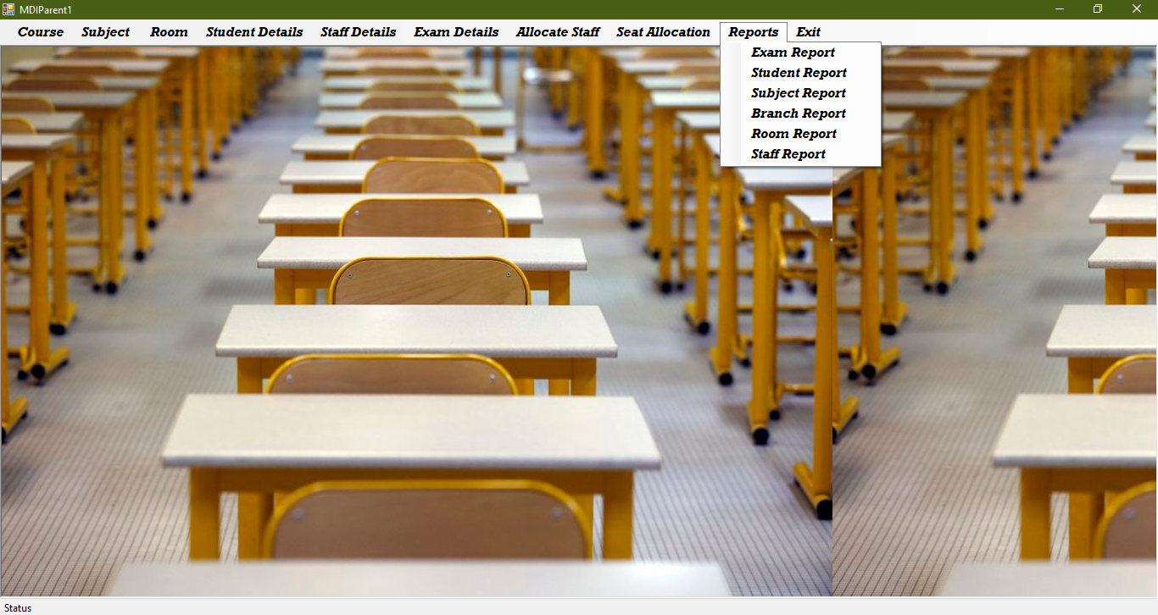

**7.2.4 Course Form**

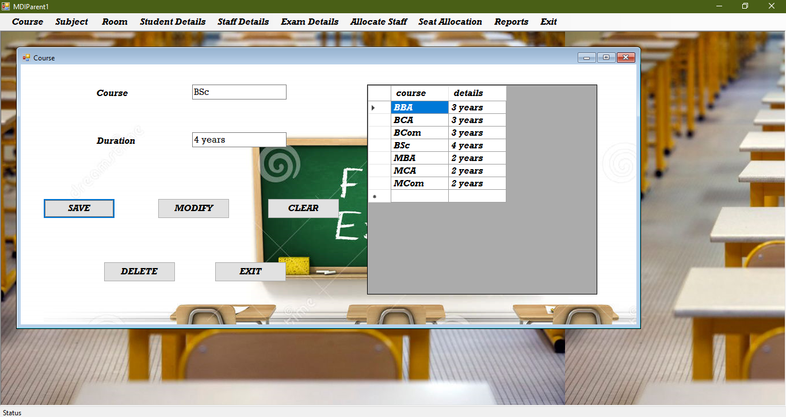

**7.2.5 Subject Form**

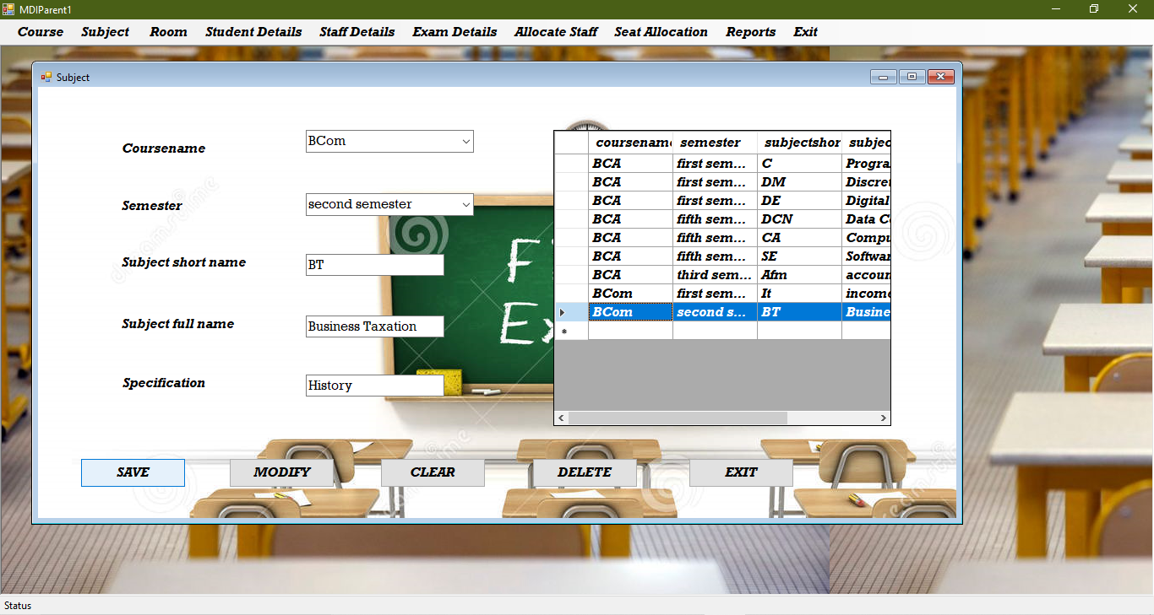

**7.2.6 Room Form**

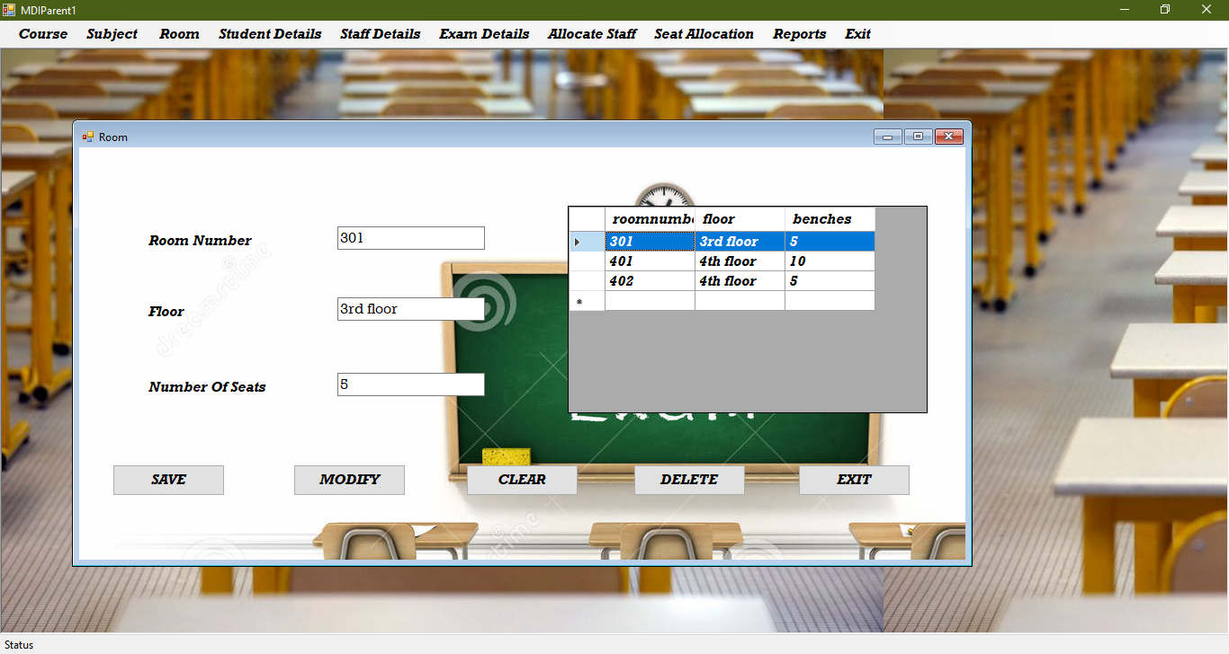

**7.2.7 Students Details Form**

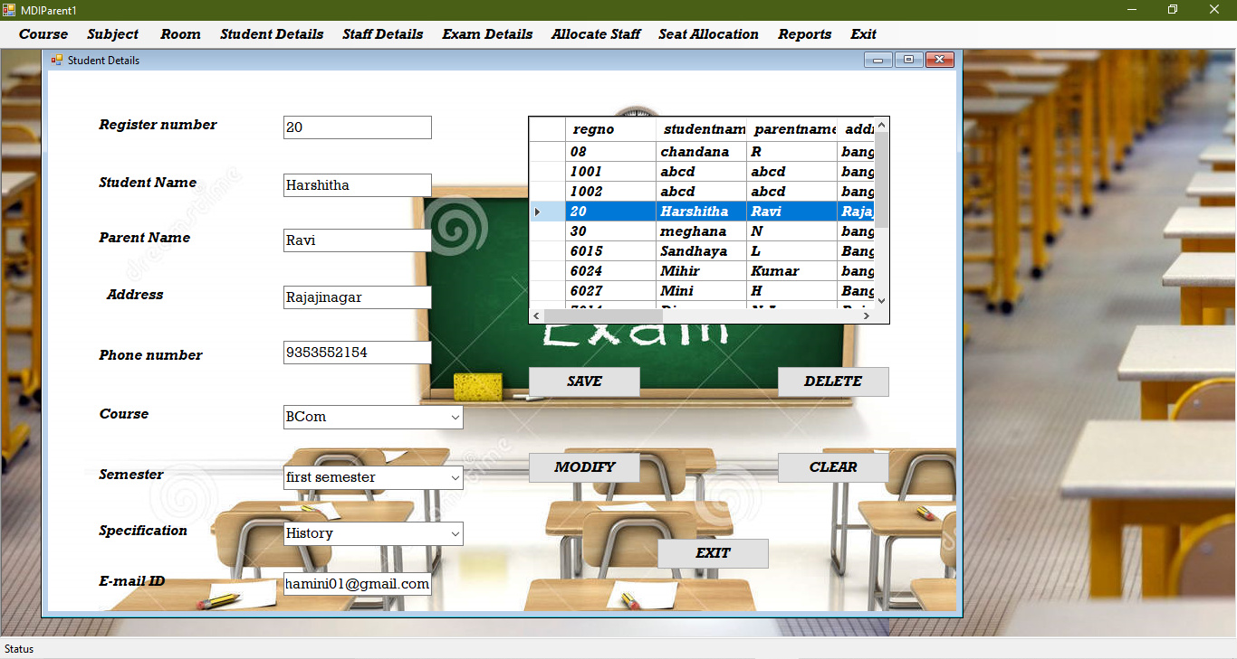

**7.2.8 Staff Details Form**

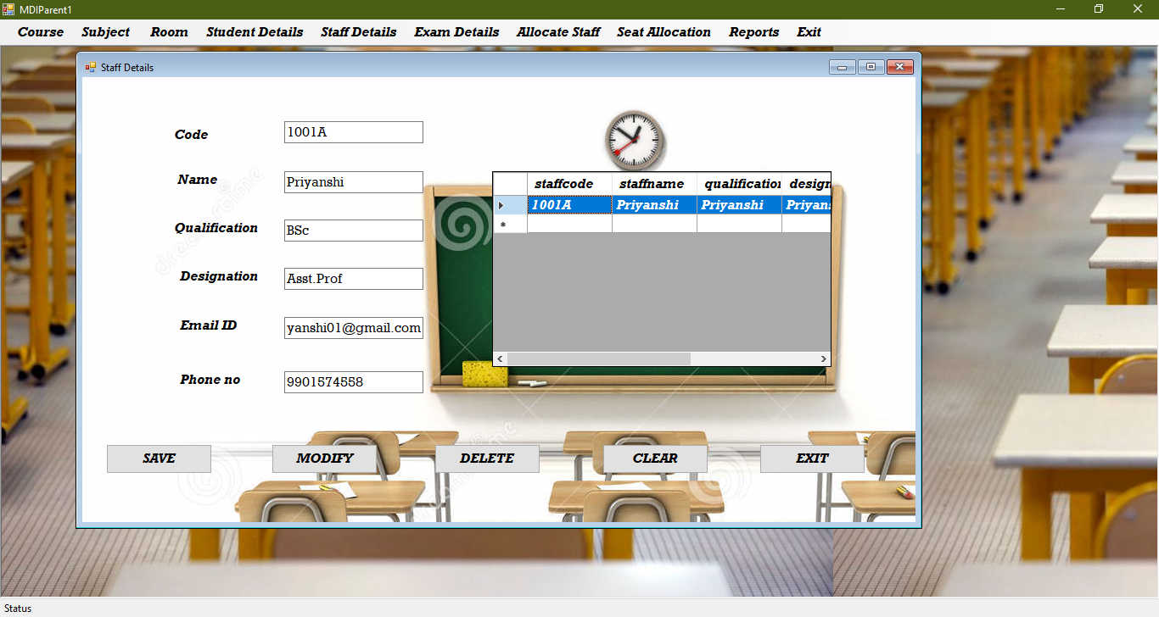

**7.2.9 Exam Details Form**

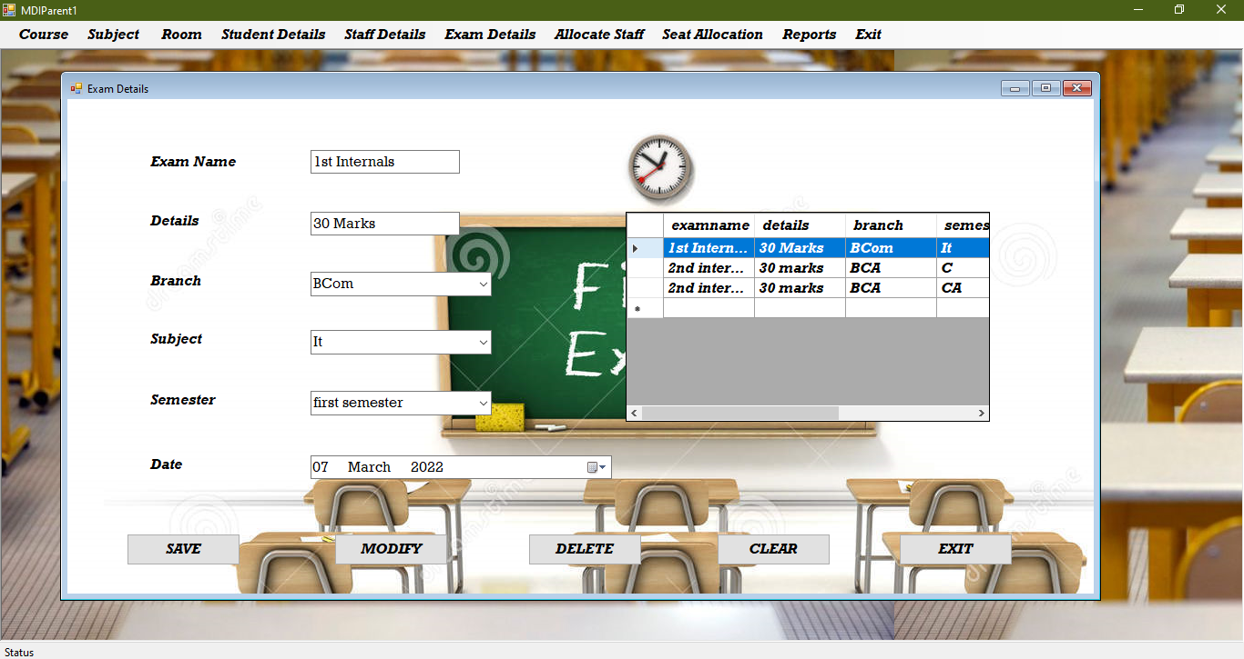

**7.2.10 Allocate Staff Form**

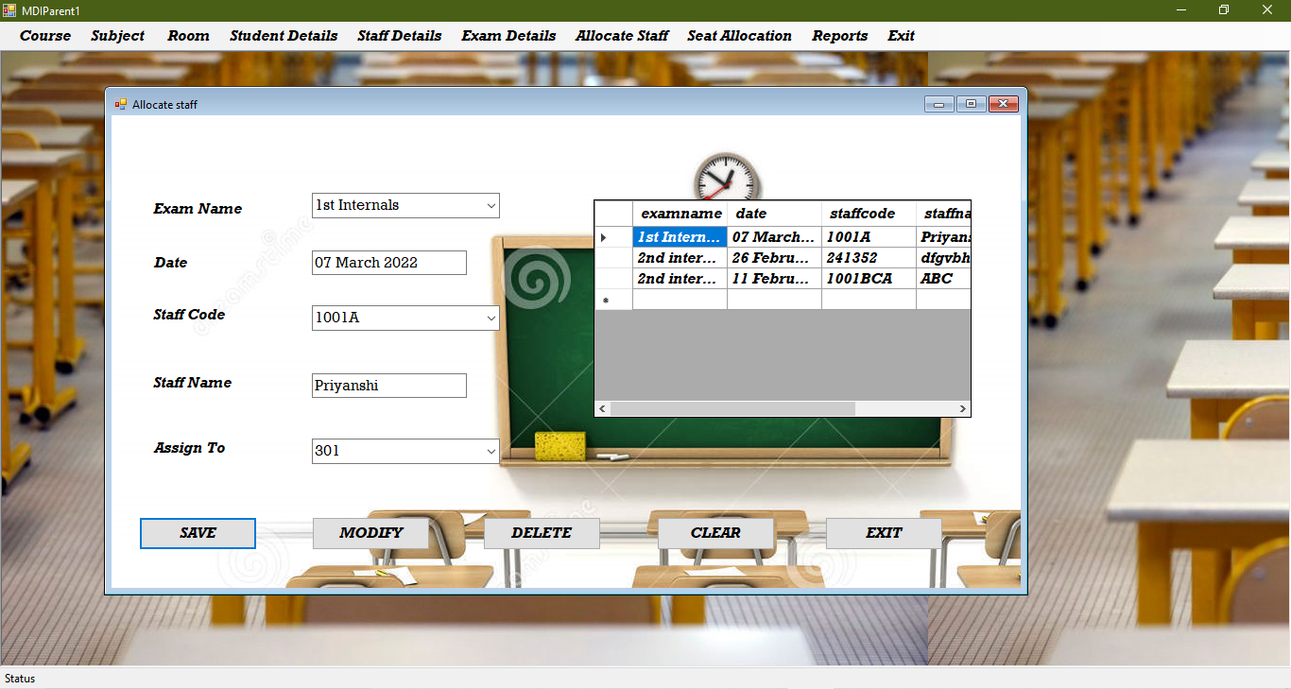

**7.2.11 Seat Allocation Form**

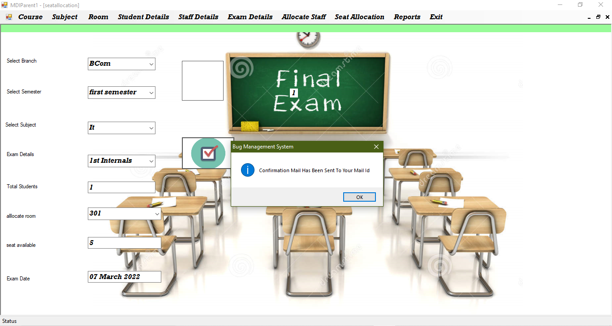

**7.2.12 Branch Report Form**

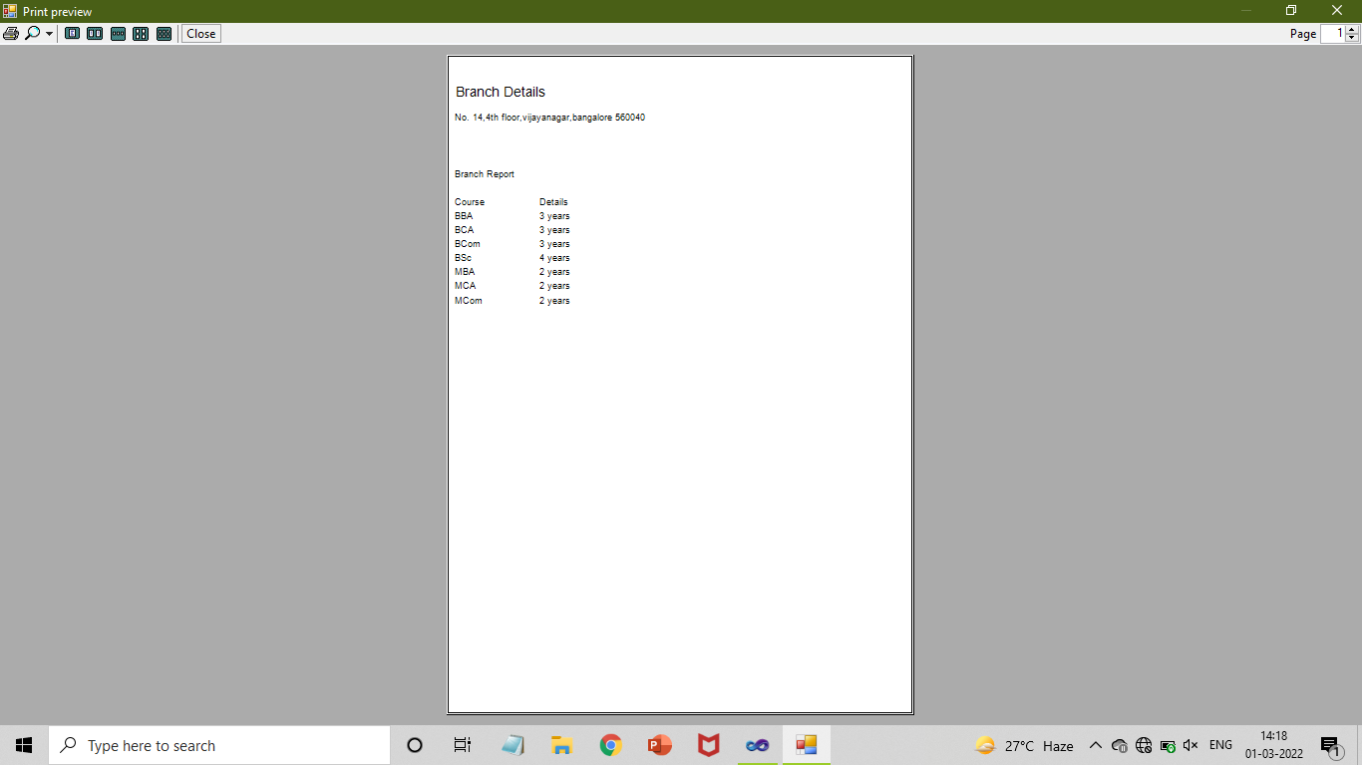

**8. TESTING**

**8.1 Test Plan**

A Test Plan is a detailed document that describes the strategy, estimation, deliverables, and resource required to perform testing for a software product. Test Plan helps us determine the effort needed to validate the quality of the application under test. The test plan serves as a blueprint to conduct software testing activities as a defined process , which is minutely and controlled by the test manager .

**8.2 Test Cases**

|  |  |  |  |  |
| --- | --- | --- | --- | --- |
| **Testcase**  **Number** | **Testing Scenario** | **Expected result** | **Actual Result** | **Result** |
| TC - 01 | Submitting form without entering the details. | Alert “ Please fill all details” | Data grid view opens | Fail |
| TC – 02 | Clicking Okay without entering Username. | Alert “ Enter Valid Username” | Alert “ Enter Valid Username” | Pass |
| TC - 03 | Clicking Okay without entering Password. | Alert “ Enter Valid Password” | Alert “ Enter Valid Password” | Pass |
| TC - 04 | Submitting form without entering valid E-mail Id. | Alert “ Invalid Email Id ” | Alert “ Invalid Email Id ” | Pass |
| TC - 05 | Submitting without entering valid phone number . | Alert “Invalid Phone Number ” | Alert “Invalid Phone Number ” | Pass |
| TC - 06 | Submitting without entering valid Name. | Alert “ Please Enter a valid Name” | Alert “ Please Enter a valid Name” | Pass |
| TC-07 | Not entering Phone Number and E-mail Id. | Alert “ Invalid Email Id”  Alert “ Invalid Email Id” | NULL value will be stored. | Fail |

**9. CONCLUSION**

This application is great advantage to all the educational institutes as it is simplifying the seating arrangement by automatically generating the seats for the students, room allocation for the staff. Project results in reduction of manpower and workload on students & staff. It benefits all the educational institutes by reducing the complexity involved while allocating the exam duty for the staff, examination rooms for the students. Data can be accessed anytime as it is stored in centralized database.

**10. BIBILOGRAPHY**

Holzner, S (2000). Visual Basic 6 Programming. Wiley

Jalote, P (1991). An integrated approach to software engineering. Narosa Publishing House.

Navathe.S.B(2010). Fundamental of Database System. Pearson Education.

WEBSITES

* <http://stackoverflow.com>
* <http://freeprojects.com>
* <http://www.w3schools.com>